Welcome to the hazardous waste truck
Thank you for bringing your hazardous waste to us and helping to keep your community healthy and safe!

Welkom by die
hazardous waste vragmotor
Thank you for bringing your hazardous waste to us and helping to keep your community healthy and safe!

Wamkelekile kwilori ye hazardous waste
Thank you for bringing your hazardous waste to us and helping to keep your community healthy and safe!

WASTE OILS
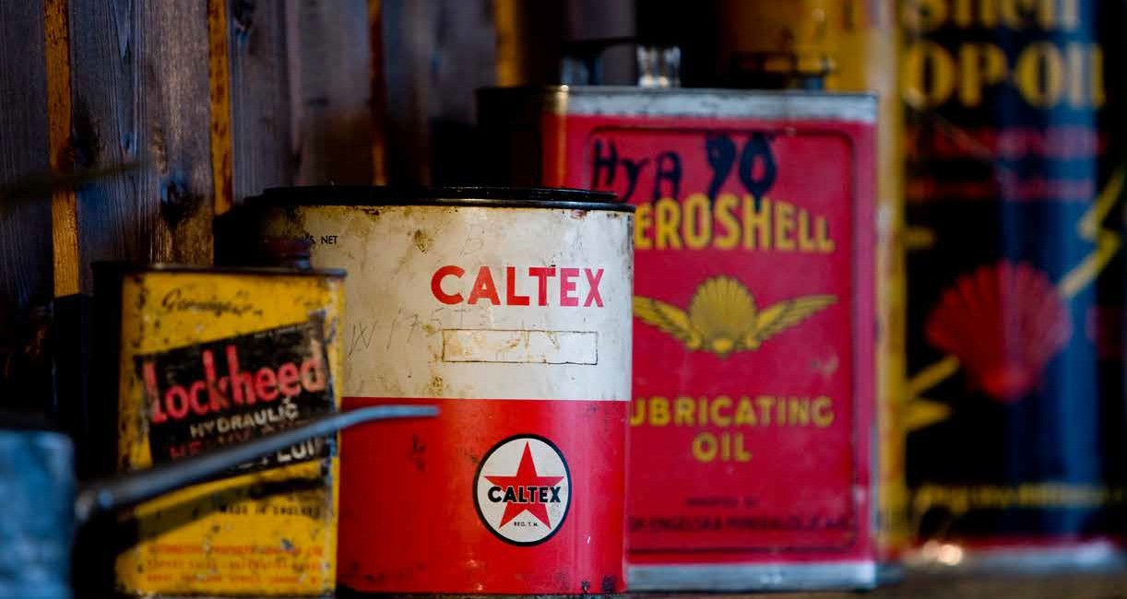
MEDICAL WASTES
INSECT REPELLENTS AND PESTICIDES
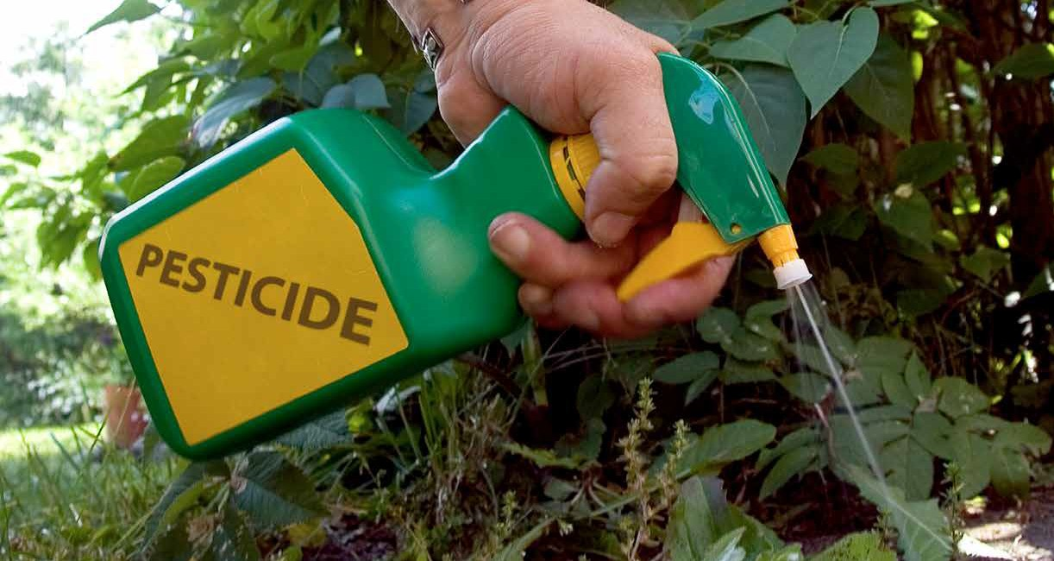
BATTERIES
CONSUMER ELECTRONICS
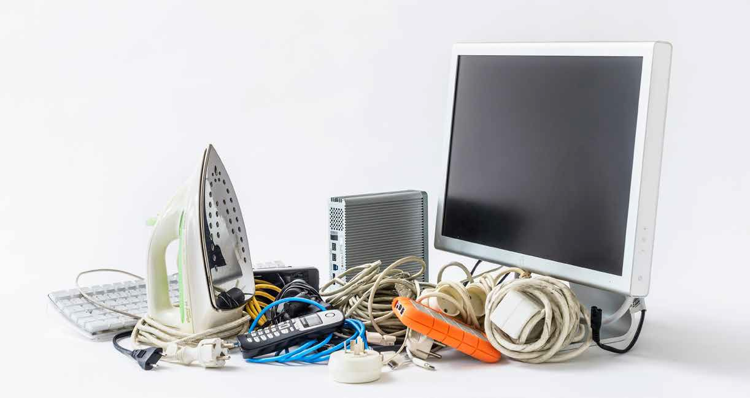
CLEANING PRODUCTS
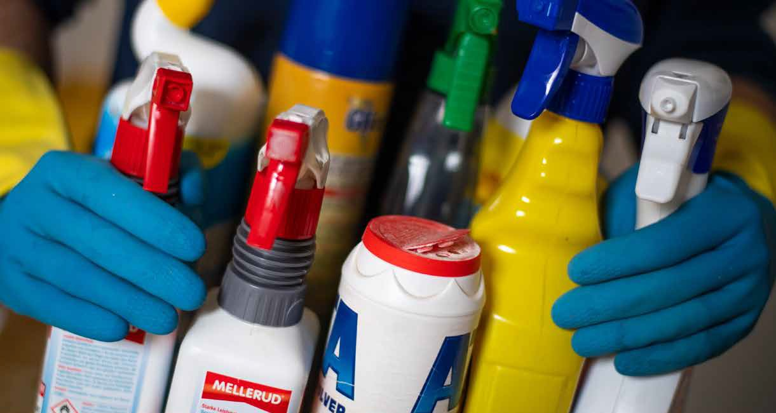
LIGHTS
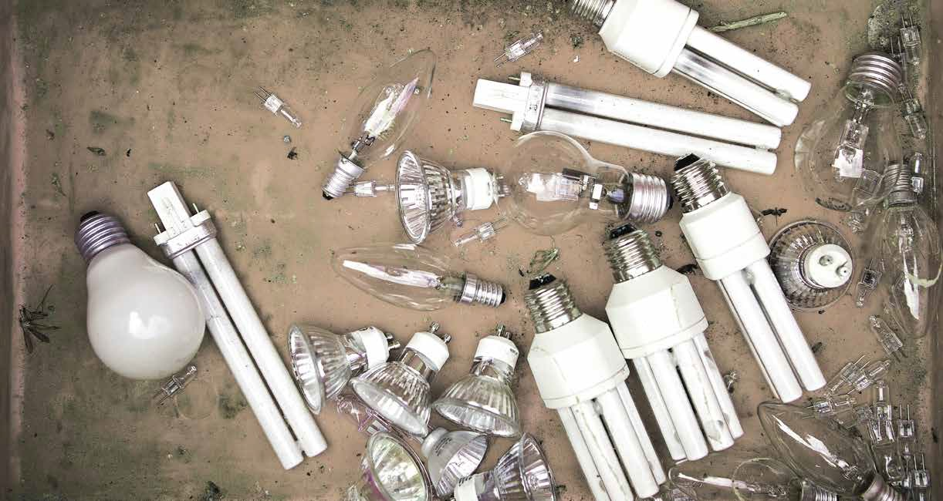
PAINTS AND SOLVENTS

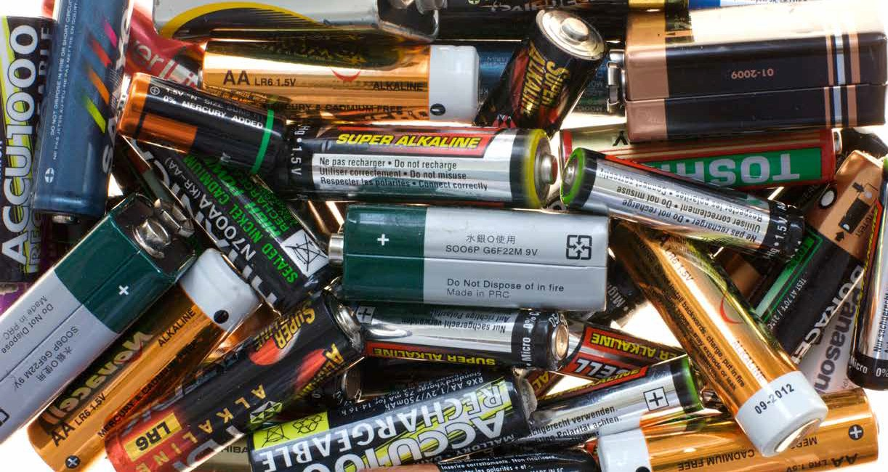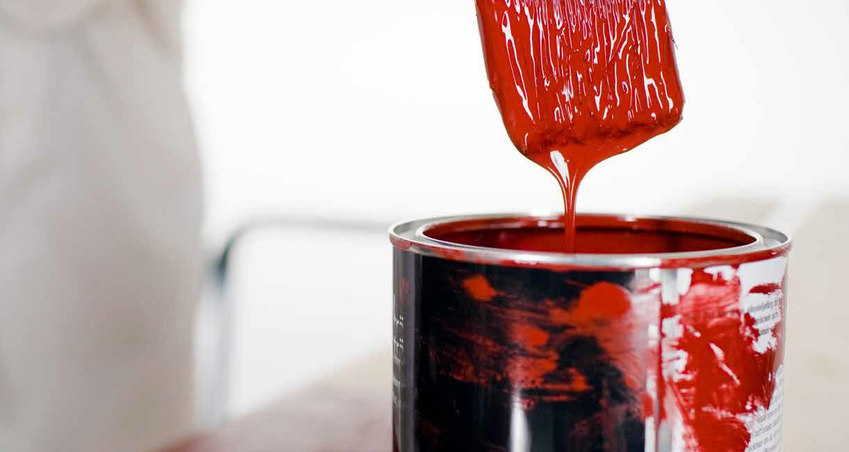

VISIT OUR WEBSITE FOR MORE INFORMATION: www.buffalocity.gov.za

