Got these hazardous waste types at home?

LIGHTS AND OTHER MERCURY CONTAINING PRODUCTS

BATTERIES

CONSUMER ELECTRONICS

PAINTS AND SOLVENTS

WASTE OILS

INSECT REPELLENTS AND PESTICIDES

MEDICAL WASTE

CLEANING PRODUCTS

Common household consumer products such as leftover medicine, unused paints and
pesticides, cleaning agents, motor oils, discarded lamps and batteries can cause significant damage to the human health and to the environment if disposed
of incorrectly when they become waste.

Municipal hazardous truck will be stopping in three areas in Buffalo City once per month. Visit www.buffalocity.gov.za for full schedule and more information about the collection.

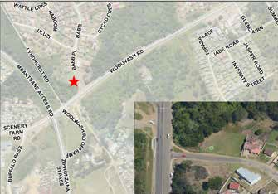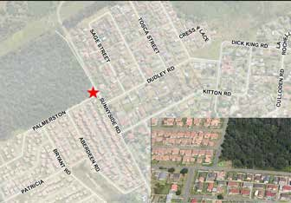
AMALINDA: Corner of Sunnyside and Woolwash (at the end of Sunnyside)
AMALINDA: Corner of Woolwash and Barb Street

COLLECTION
THURSDAY: 17/2, 17/3, 21/4, 19/5, 23/6 11 AM–1.30 PM
COLLECTION
THURSDAY: 17/2, 17/3, 21/4, 19/5, 23/6

BRING YOUR HAZARDOUS WASTE TO THE HAZARDOUS WASTE TRUCK!
DON’T THROW IT IN THE GARBAGE OR POUR IT DOWN
THE DRAIN.
2-5 PM

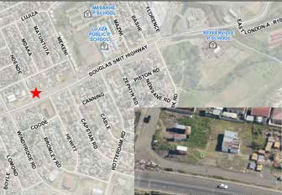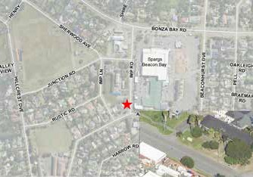
DUNCAN VILLAGE: Douglas Smith Highway (next to Boxer)
BEACON BAY: next to Spargs Complex

COLLECTION
FRIDAY: 18/2, 18/3, 22/4, 20/5, 24/6
2–5 PM
COLLECTION
SATURDAY: 19/2, 19/3, 23/4, 21/5, 25/6
12-3 PM

HOUSEHOLD HAZARDOUS WASTE PILOT PROJECT IS IMPLEMENTED BY BUFFALO CITY METRO MUNICIPALITY IN PARTNERSHIP WITH THE DEPARTMENT OF ENVIRONMENT, FORESTRY AND FISHERIES AND THE SWEDISH ENVIRONMENTAL PROTECTION AGENCY.

