Got these hazardous waste types at home?

LIGHTS AND OTHER MERCURY CONTAINING PRODUCTS
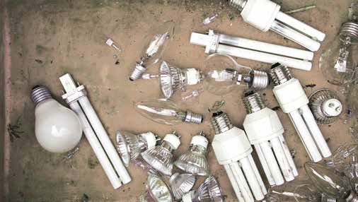

CLEANING PRODUCTS
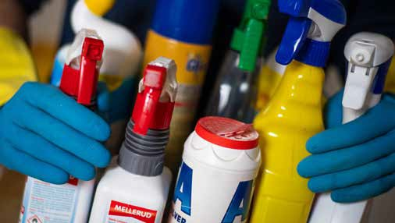

BATTERIES

WASTE OILS
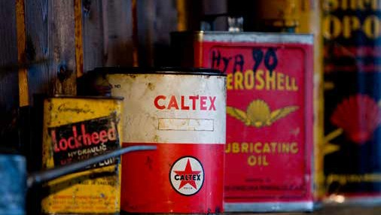

INSECT REPELLENTS AND PESTICIDES
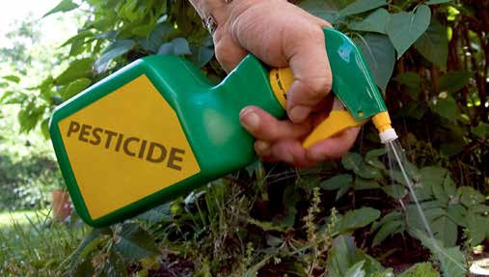

PAINTS AND SOLVENTS

CONSUMER ELECTRONICS
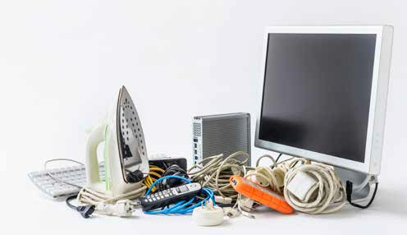

MEDICAL WASTES

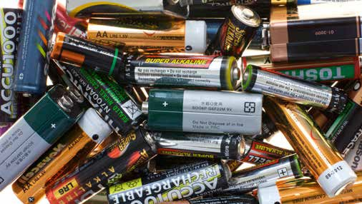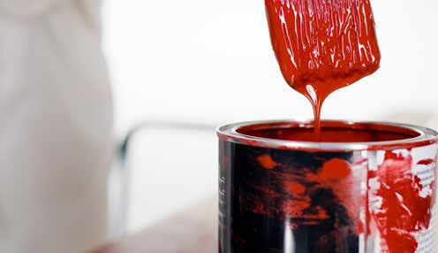
Visit www.buffalocity.gov.za
for more information.

Hazardous waste truck will stop at designated sites in Buffalo City on specific dates.

BRING YOUR HAZARDOUS WASTE TO THE HAZARDOUS WASTE TRUCK!
DON’T THROW IT IN NATURE OR POUR IT DOWN THE DRAIN.
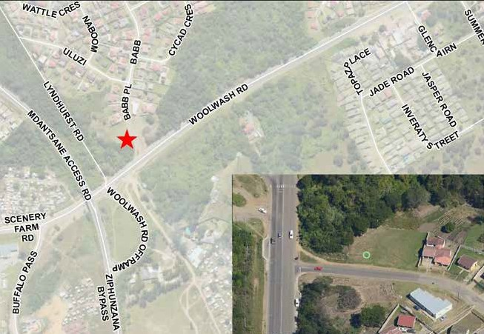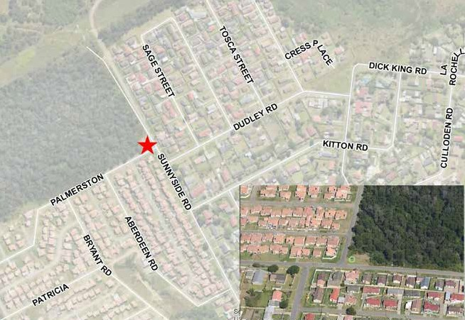
AMALINDA: Corner of Sunnyside and Woolwash (at the end of Sunnyside)
AMALINDA: Corner of Woolwash and Barb Street

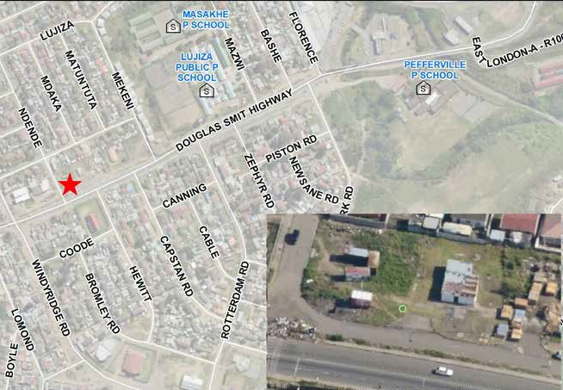 KICK OFF 17 FEBRUARY 11 AM–1.30 PM
DUNCAN VILLAGE: Douglas Smith Highway (next to Boxer)

KICK OFF 18 FEBRUARY 2–5 PM
KICK OFF 17 FEBRUARY 2–5 PM
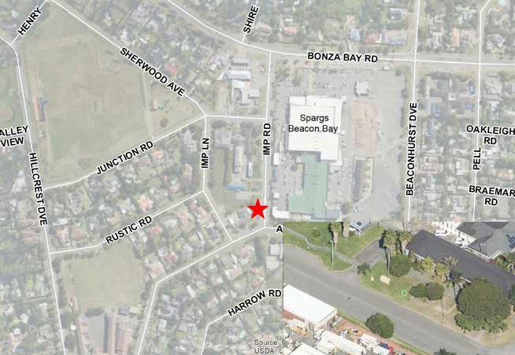
BEACON BAY: next to Spargs Complex
KICK OFF 19 FEBRUARY 12–3 PM

HOUSEHOLD HAZARDOUS WASTE PILOT PROJECT IS IMPLEMENTED BY BUFFALO CITY METRO MUNICIPALITY IN PARTNERSHIP WITH THE DEPARTMENT OF ENVIRONMENT, FORESTRY AND FISHERIES AND THE SWEDISH ENVIRONMENTAL PROTECTION AGENCY.

