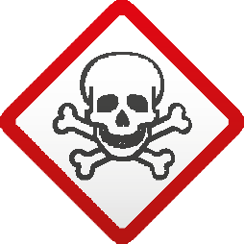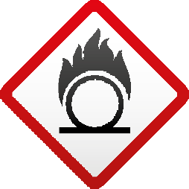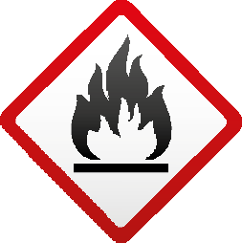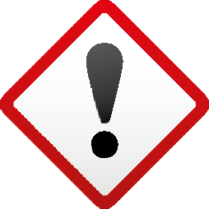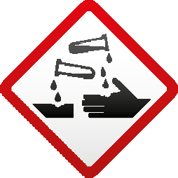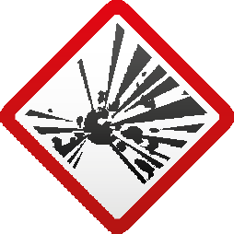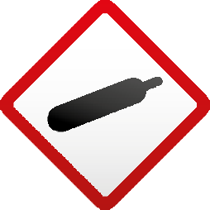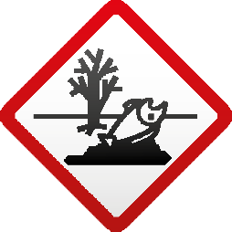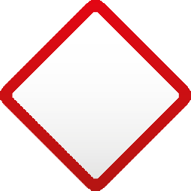

Here are some examples of products with hazardous properties

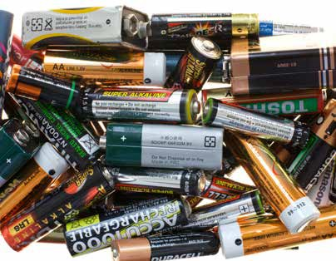
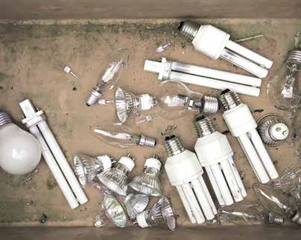
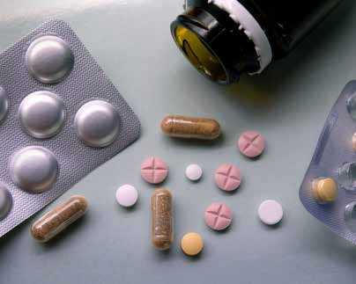
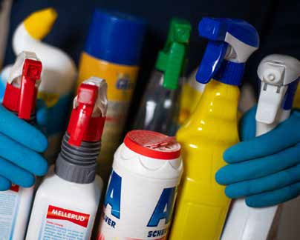
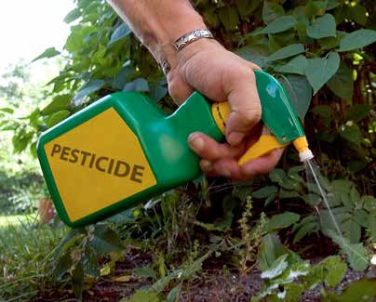
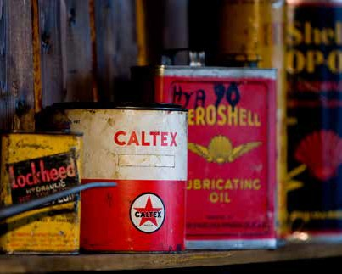
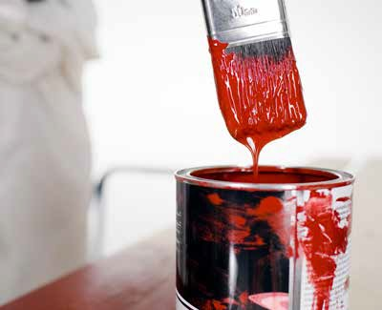
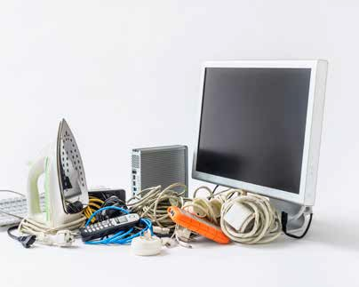
BATTERIES
- Portable batteries
- Battery operated electronics and toys
- Button batteries
LAMPS AND OTHER MERCURY CONTAINING PRODUCTS
- Fluorescent tubes
- Low energy light bulbs
- Discarded or broken thermometers
- Discarded or broken barometers
MEDICAL WASTE
Unused, unwanted or expired
- Drugs
- Medicines
- Used injections
- Pills
CLEANING PRODUCTS
- Shoe polish
- Antifreeze
- Cleaning agent for grill or oven
- Cleaning agent for plumbing
INSECT REPELLENTS AND PESTICIDES
- Ant poison
- Rat poison
- Fungicides
- Insecticides
WASTE OILS
- Leftover gasoline/diesel
- Motor oil
- Oil filters from cars/ trucks
PAINTS AND SOLVENTS
- Leftover water based paint
- Oil based paint
- Hobby or artist paint
- Aerosoles
- Paint remover
CONSUMER ELECTRONICS
- All small consumer electronics with electrical cord
- All consumer electronics and electrical devices powerd by a battery.

Products with these labels are typically hazardous waste when disposed. Don’t throw them in nature or pour it down the drain.
Bring them to the hazardous waste truck!

What is hazardous about…
LAMPS Low energy light bulbs and fluorescent lights contain mercury. Mercury is a heavy metal that accumu- lates in human bodies and animals. It does not break down and is very toxic. One teaspoon of mercury can poison a medium sized lake.
BATTERIES can contain heavy metals such as mercury, cadmium and lead. If you eat fish and animals exposed to heavy metals, they are transferred to your body which can damage your nervous system, kidneys and bones.
Some products such as smart phones operate on lithium batteries, a substance that is very flammable and can cause fires that are very hard to put down.
What is so hazardous about hazardous waste?
The average household uses various consumer products that contain ingredients that can cause significant damage to the human health and the environment if handled and disposed of incorrectly. If thrown in the garbage that end up in land- fills, dumped in nature or poured down the drain, hazardous properties in the consumer products can leak into the eco- system and affect animals and the environment. When we
in turn eat or drink contaminated food and water it can have a negative effect on our and our children’s health. Even in small quantities some hazards can cause major harm.

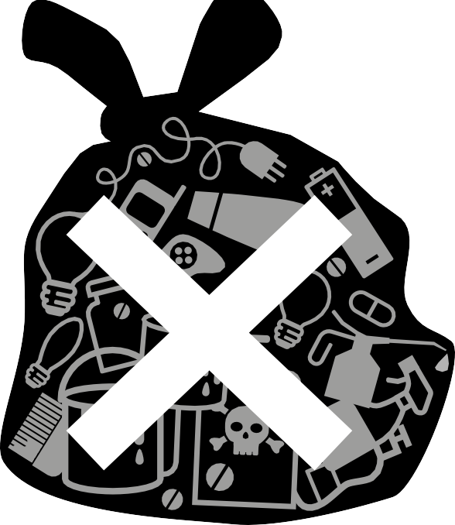
MEDICAL WASTES contains chemical properties that can be beneficial for your health but harmful to other living organisms if poured down the drain or flushed down the toilet. Discarded drugs can contaminate our waterways and drinking waters since our sewage treat- ment system are not effective in removing drugs from
the water. For example, if hormonal medication is flushed down the toilet, they can affect the fertility of fish and other marine animals.
INSECTICIDES AND PESTICIDES contain toxic chemi- cals that are meant to kill pests. They can be very harm- ful if they reach a destination other than their target.
They can leak into the air, water, sediments and even end up in the food we eat. Pesticides can cause short term impacts on our health such as headaches to long term impacts such as cancer and reproductive harm.
CLEANING PRODUCTS: The most common ingredients in household cleaning products include alkalis, acids and detergents. Alkalis are soluble salts that are effective in removing dirt without excessive rubbing. Alkalis vary in strength; the stronger one cause burns, and if swallowed can cause internal injuries and even death. Acids are beneficial in removing hard-water deposits, discoloration and rust stains. Acids can irritate and injure the skin and eyes. Oxalic acid, used in some toilet bowl cleaners, is extremely poisonous.
WASTE OILS can irritate the skin causing rash or burns. Breathing mineral oils can irritate the lungs. Many mineral oils are also very flammable and burn easy.
PAINTS AND SOLVENTS contain substances such as solvents, pigments and additives that can be both hazardous and non-hazardous. Since it is difficult to distinguish different types of paints, we need to treat them as hazardous.
CONSUMER ELECTRONICS contain many different components that are made of heavy metals and other chemical compounds that might pose potential health risk if burnt or disposed of incorrectly. Ingredients such as lead, mercury, arsenic, cadmium, copper, nickel and chromium are used in circuit boards and comprise electrical parts such as computer chips, monitors and wiring.

LIGHTS AND OTHER MERCURY CONTAINING PRODUCTS

WASTE OILS
PAINTS AND SOLVENTS

CONSUMER ELECTRONICS

MEDICAL WASTE
INSECT REPELLENTS AND PESTICIDES

WASTE OILS

BATTERIES

CLEANING PRODUCTS

