What hazardous waste
do you have in your home?
Visit our website for more information about the pilot, what is considered hazardous waste and how you can identify it in your home.

Where does the hazardous waste truck come and when?

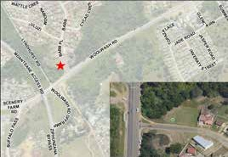THURSDAY 17/2, 17/3, 21/4,
AMALINDA: Corner of Sunnyside and Woolwash (at the end of Sunnyside)
19/5, 23/6
11 AM–1.30 PM

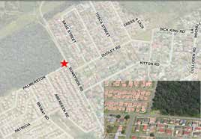THURSDAY 17/2, 17/3, 21/4,
AMALINDA: Corner of Woolwash and Barb Street
19/5, 23/6
2–5 PM

Got these hazardous waste types at home?
Don’t throw it in nature or pour it down the drain. Bring it to the municipal hazardous waste truck and help to keep your community healthy and clean!
Buffalo City Metro Municiaplity is launching a pilot project to collect hazardous waste from households in Duncan Village, Beacon Bay and Amalinda.
Learn more about what is hazardous waste and how to dispose of it correctly.

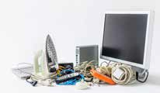
WASTE OILS CONSUMER ELECTRONICS

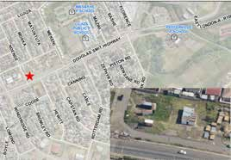FRIDAY
DUNCAN VILLAGE: Douglas Smith Highway (next to Boxer)
18/2, 18/3, 22/4,
20/5, 24/6
2–5 PM

MEDICAL WASTES

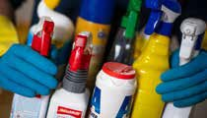
CLEANING PRODUCTS

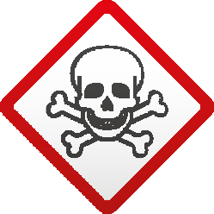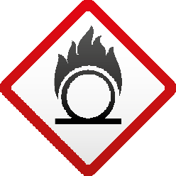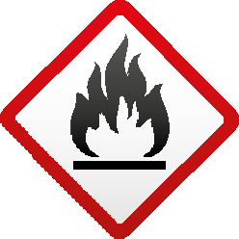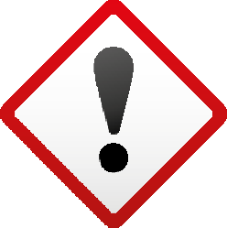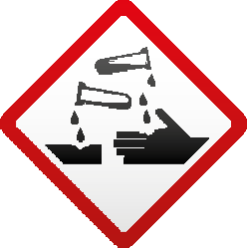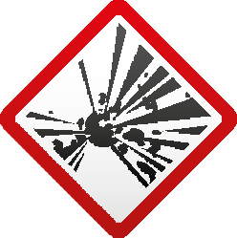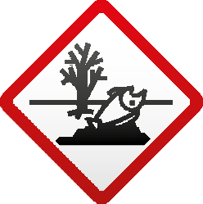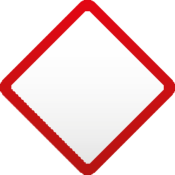
CONTACT INFORMATION
Got questions?
Visit our website for more information about the pilot project
Contact person: Ms N. Daniel, Department of Solid Waste Office telephone: 043 705 2845/6/7
E-mail: nomphelod@buffalocity.gov.za and
amkelaj@buffalocity.gov.za.

www.buffalocity.gov.za

HOUSEHOLD HAZARDOUS WASTE PILOT PROJECT IS IMPLEMENTED BY BUFFALO CITY METRO MUNICIPALITY IN PARTNERSHIP WITH THE DEPARTMENT OF ENVIRONMENT,
FORESTRY AND FISHERIES AND THE SWEDISH ENVIRONMENTAL PROTECTION AGENCY.
SATURDAY 19/2, 19/3, 23/4,
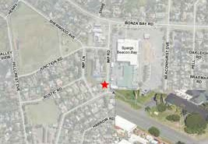21/5, 25/6
BEACON BAY: next to Spargs Complex
12–3 PM

INSECT REPELLENTS AND PESTICIDES
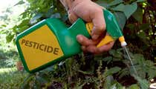

BATTERIES
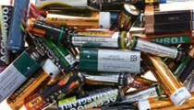

LIGHTS AND OTHER MERCURY CONTAINING PRODUCTS
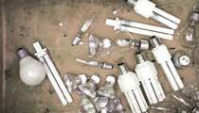

PAINTS AND SOLVENTS
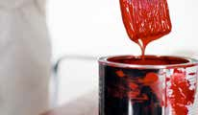

What hazardous products do I have in my home?
The average household use various hazardous products that contain ingredients that can cause significant damage to the human health and the environment
if disposed of incorrectly.
For example pesticides used in a household garden and certain cleaning products are potentially very toxic to human health. Also various items used to maintain automobiles such as gasoline, oil, antifreeze and battery accumulators can be flammable, ecotoxic

EXAMPLES OF HOUSEHOLD PRODUCTS CONTAINING HAZARDOUS SUBSTANCES
BATTERIES
- Portable batteries
- Battery operated electronics and toys
- button batteries
PESTICIDES AND INSECTICIDES
- Ant poison
- Herbicides
- Insecticides
- Rat poison
- Fungicides
LAMPS AND OTHER MERCURY CONTAINING PRODUCTS
- Fluorescent tubes
- Low energy light bulbs
- Discarded or broken thermometer
- Discarded or broken barometer
OLD OR DISCARDED MEDICINES
- Drugs
- Medicines
- Used injections
- Pills

MINERAL OILS
- Waste oil
- Oil filters from car/trucks
- Fire starter for braai
PAINTS AND SOLVENTS
- Leftover paint
- Paint remover (ethylene glycol, methyl dipropoxol)
CLEANING AGENTS
- Floor polish
- Furniture polish
- Shoe polish
- Stain remover
- Disinfectant and bleach-based products
- Air refresher
- Cleaning agent for oven/grill
- Cleaning agent for pipes
CONSUMER ELECTRONICS
- All electrical and electronical devices with electrical cord or battery

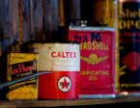

and carcinogenic. Consumer electronics, low energy lightbulbs and batteries contain heavy metals that are very toxic for both humans and the environment even in very small doses.
Don’t throw hazardous waste in nature and don´t pour
it down the drain. Store it safely in your home and bring it to the hazardous waste truck. We will make sure that it’s disposed of safely.
The hazardous waste truck is a mobile truck that stops once per month in designated areas and is operated by drivers licensed to transport hazardous goods and
staff educated to identify and receive hazardous waste.

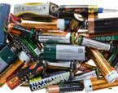
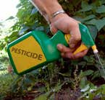

Who will collect my waste?
The hazardous waste truck is operated by municipal staff that are trained and licensed to collect and transport hazardous goods. The staff is also trained to answer questions on how to identify hazardous waste.

What can I bring to the hazardous waste truck?
- Leftover paints, cleaning products, mineral oils, pesticides and insecticides.
- Electrical and electronical devices (no bigger
than a microwave), discarded batteries (other than lead acid batteries) and lamps
- Medical waste (pills, liquid and patch)

REMEMBER
- If you are unsure if the waste is hazardous, bring it anyway and ask our staff to help you identify the content.
- Keep the product in its original container with the label intact.
- Store products out of reach of children and pets, away from heat and away from the house (if possible).
- Bring to the hazardous waste truck even if the amount of waste is small!

DO NOT BRING!
- Explosive waste
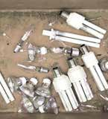
- Electrical and electronical devices bigger than a microwave (tv, fridge, vacuum cleaner etc.)
- Car batteries
- Radioactive waste
- Lead acid batteries
- Any other type of waste (packaging, bulky waste etc.)

