BCMM Household Hazardous Waste Source Separation Pilot Project

Task
The task is to identify approximately 500-1000 cohesive households/homes in four areas in the Costal Region in BCMM that will be part of the pilot study focusing on source separation of household hazardous waste.

Overall project objective
The proposed solid waste management project strives for diversion of household hazardous waste through separation at source and environmentally sound management of this waste stream. The long term objective is to reduce the environmental degradation caused by these waste streams.

Study areas and number of households:
- Beacon Bay (high income area) = 1000 households

- Amalinda (middle income area/working class area) = 1000 households

- Duncan Village = 1500 households (500 from formal settlement, 500 from formal with backyard dwellings and 500 from information squatters). It would be preferable if all the three settlement forms could be clustered together in one area.

Concise description of the project
The proposal for solid waste management pilot project is aimed at starting up waste separation at source of the household hazardous waste (HHW) that is generated at household level. It is believed that this will ultimately enable / assist the Buffalo City Metropolitan Municipalitiy (BCMM) towards meeting the legal requirements of the National Environmental Management: Waste Act (Act No. 59 of 2008) and associated Regulations and Norms and Standards that require diversion of listed wastes including hazardous waste from landfill disposal. After a period of twelve months the intention is draw a plan on how to extend the Pilot Project to all areas of BCMM.

Name of the project
Household hazardous waste – pilot project in BCMM

Project leader
Ms Nomphelo Daniel – BCMM
Ms Nina Avdagic Lam/Isabelle Groth – Swedish EPA
Per-Olof Hallberg – Gastrike Återvinnare

Responsible organisation
Department of Environmental, Forestry and Fisheries, Pretoria
Department of Solid Waste Management Services, Buffalo City Metropolitan Municipality

Background to the project
The economic group BRIICS consists of Brazil, Russia, India, Indonesia, China and South Africa. As a member country of the economic group, South Africa is one of the most dominant economies. In 2015, Swedish delegations including representatives from the Environment and Energy Department along with representatives from other state authorities visited South Africa to strengthen the cooperation in the environmental field. The visit was associated with the Sweden-South Africa Binational Commission which took place in Stockholm on 19.-20 October 2015. During the BNC meeting, a letter of intent was signed to initiate the cooperation in the area of environmental protection and climate. The cooperation between the Swedish EPA (SEPA) and Department of Environmental Affairs (DEA) of the Republic of South Africa put focus on waste management.

South Africa is a new country partner to the SEPA in the environmental field. In May 2016, SEPA started the partnership by visiting Pretoria and held a discussion on which issues should be prioritized in waste management. The SEPA contributed with a thorough review on the development of waste management in Sweden and EU, as well as EU’s management on export and import of waste. After the dialogue, a long list was produced regarding to the waste management.

In September 2016, a workshop of waste management and a number of visits were organised in Sweden for en delegation from the Department of Environmental Affairs. During the workshop’s final discussion, one list of prioritized issues was created, leading to a suggested project on hazardous household waste management with different types of municipalities as entry point.

The DEA has identified BCMM amongst other municipalities for piloting of waste management projects. On the 28 July 2017, an inception workshop was hosted with representatives from the International Relations, Municipal Services, Solid Waste Management Services and Municipal Health Services Departments of BCMM, Provincial Department of Economic Development Environmental Affairs and Tourism (DEDEAT), DEA as well as SEPA.

The DEA has identified the BCMM as one of the six municipalities that they would want to work with to jointly implement two waste management pilot programmes. The proposed waste management pilot programmes are:

Zero Waste Strategy, for diversion of certain waste streams for landfill disposal; as well as
Household hazardous waste management to ensure that the hazardous waste generated at the household level is separated from the other general waste collected by the municipality.

The SWMS welcomed the above proposed programmes as these will assist the municipality in ensuring compliance with the recently promulgated National Norms and Standards for Disposal of waste by Landfill. These Norms and Standards require the municipalities to prohibit landfill disposal of the listed wastes within the listed timeframes. Also, although hazardous waste is generated at the household level, the BCMM has no licenced waste management facility for hazardous waste. It is against this background that the municipality believes that the programmes will be of value to BCMM.

Decription of the problem to be solved
To date very little work has been undertaken on HHW management across the country and hence very little information is available on how this waste stream is managed. Although there is a national waste information system – South African Waste Information System (SAWIS) that requires waste generators to register and for the waste managers to report on how the waste is managed; the generators of general waste, i.e. households, are excluded from the reporting. Furthermore, household generators of domestic waste are excluded from the various pieces of legislation governing waste as listed above. Although there is a National Policy on Domestic Waste Collection Standards the standards do not differentiate the hazardous waste component from the general waste component of domestic waste. Similarly the National Policy for Provision of Basic Refuse Removal Services does not differentiate the waste types.

The pilot project will identify and evaluate the potential methodologies for the diversion of the hazardous waste component from the municipal waste collected from households and will pilot HHW separation within designated areas.

Target groups
The primary target groups are the households within the pilot project and municipal council of BCMM. Another important target is the staff working with waste management in BCMM.

Municipalties
The BCMM will assist the project by providing the necessary infrastructure as well as in kind resources to facilitate collection of the hazardous portion of household waste.

The public
It is important that the public i.e. ordinary citizens, private and public institutions whose waste is managed and whose environment is improved is actively involved in the project. An important step to motivate and engage the public is through continuous public awareness campaigns based on information, education and communication strategy. In addition a sense of ownership of the project should be created for each household to ensure their participation in the project.

Youth clubs and eco-clubs
Potentially youth groups and eco-clubs at school will be engaged in the project via continuous school intervention programmes.

Business/Industry
Partnerships will be sought with local companies for financial contributions as well as donations of collection scemes for collection and storage of the separated hazardous waste and for transportation and treatment. Businesses will also be able to assist the project by providing secured storage sites, sponsor the project and in return receive marketing/publicity.

Other Government Departments
The government departments e.g. DEA and DEDEAT will assist and give guidance regarding waste management facility licence requirements.

Locations of Collection
Amalinda’s collection will take place once a month on Thursdays at 2 different collection sites at different times. Dates and times will be confirmed.
Duncan Village collection days will be once a month on Fridays.
Beacon Bay collections will be once a month on Saturday mornings.

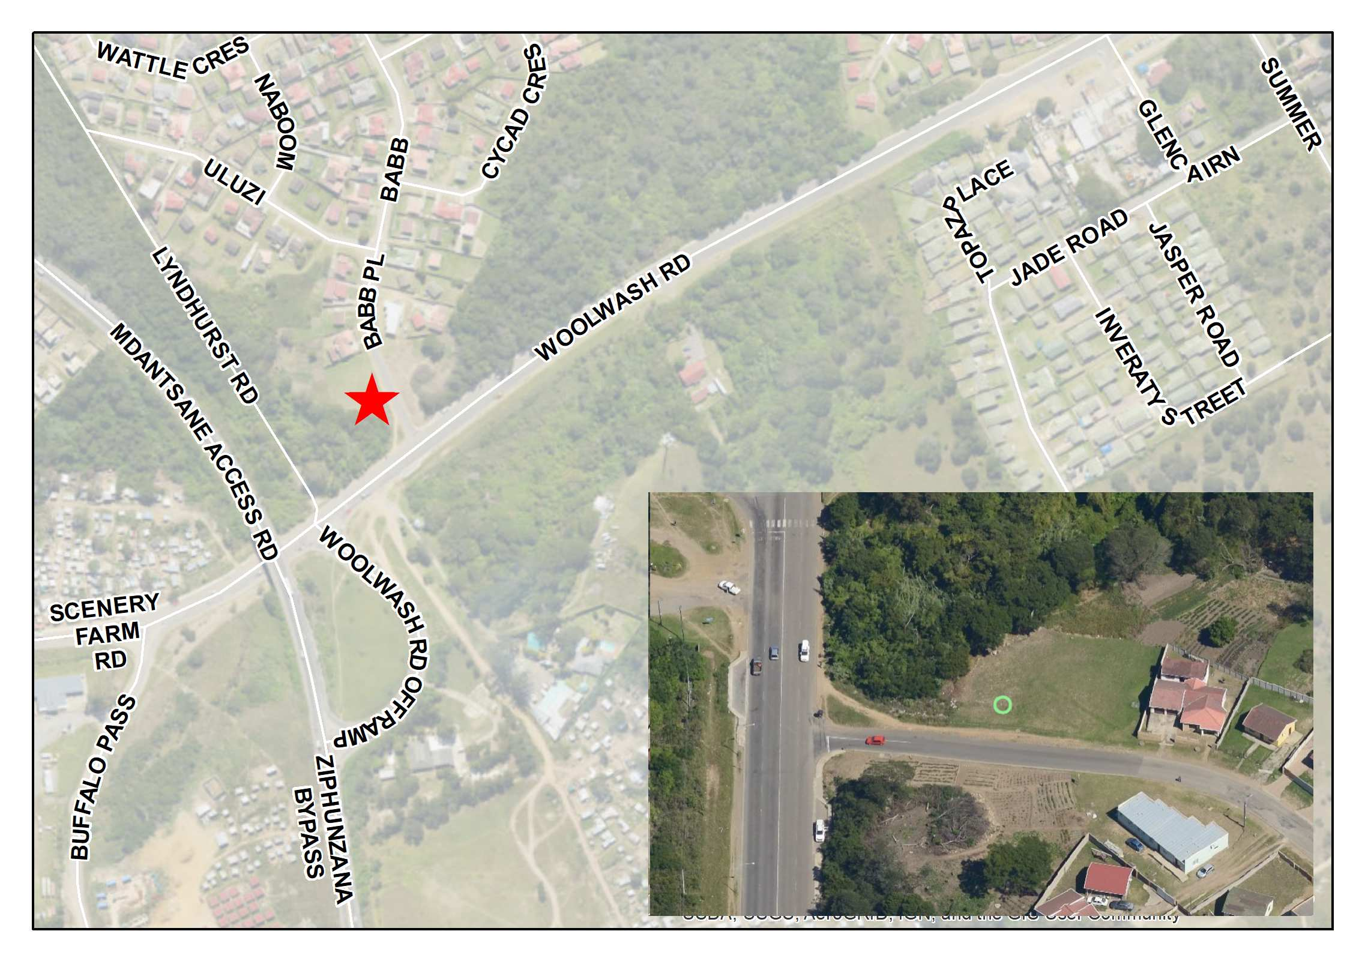
Amalinda collection site 1 at Woolwash Road.

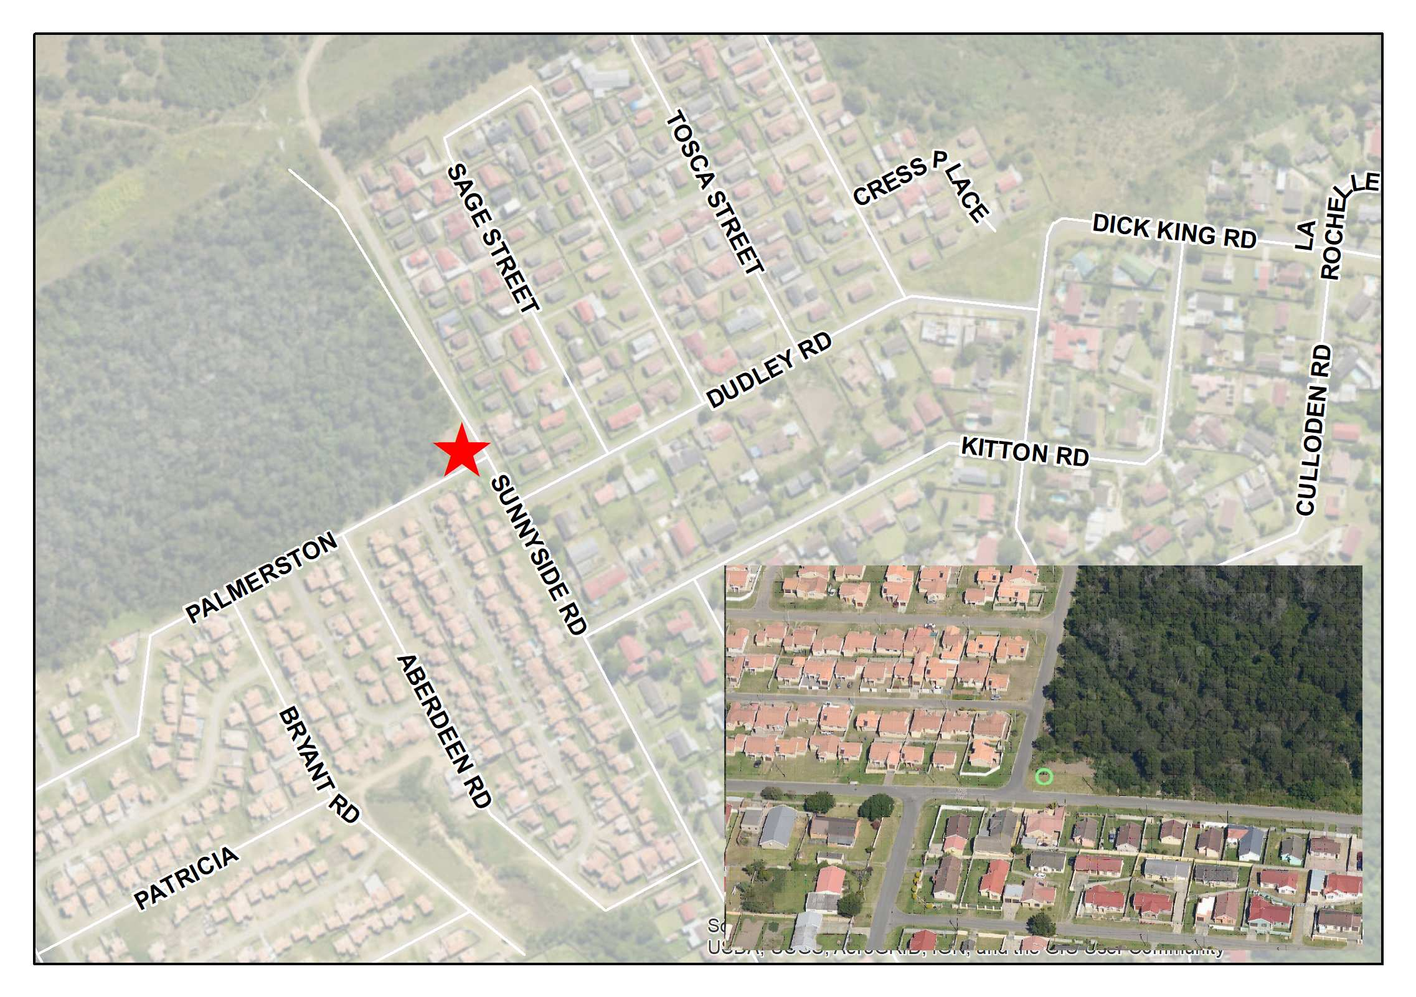
Amalinda collection site 2 at Sunnyside Road.

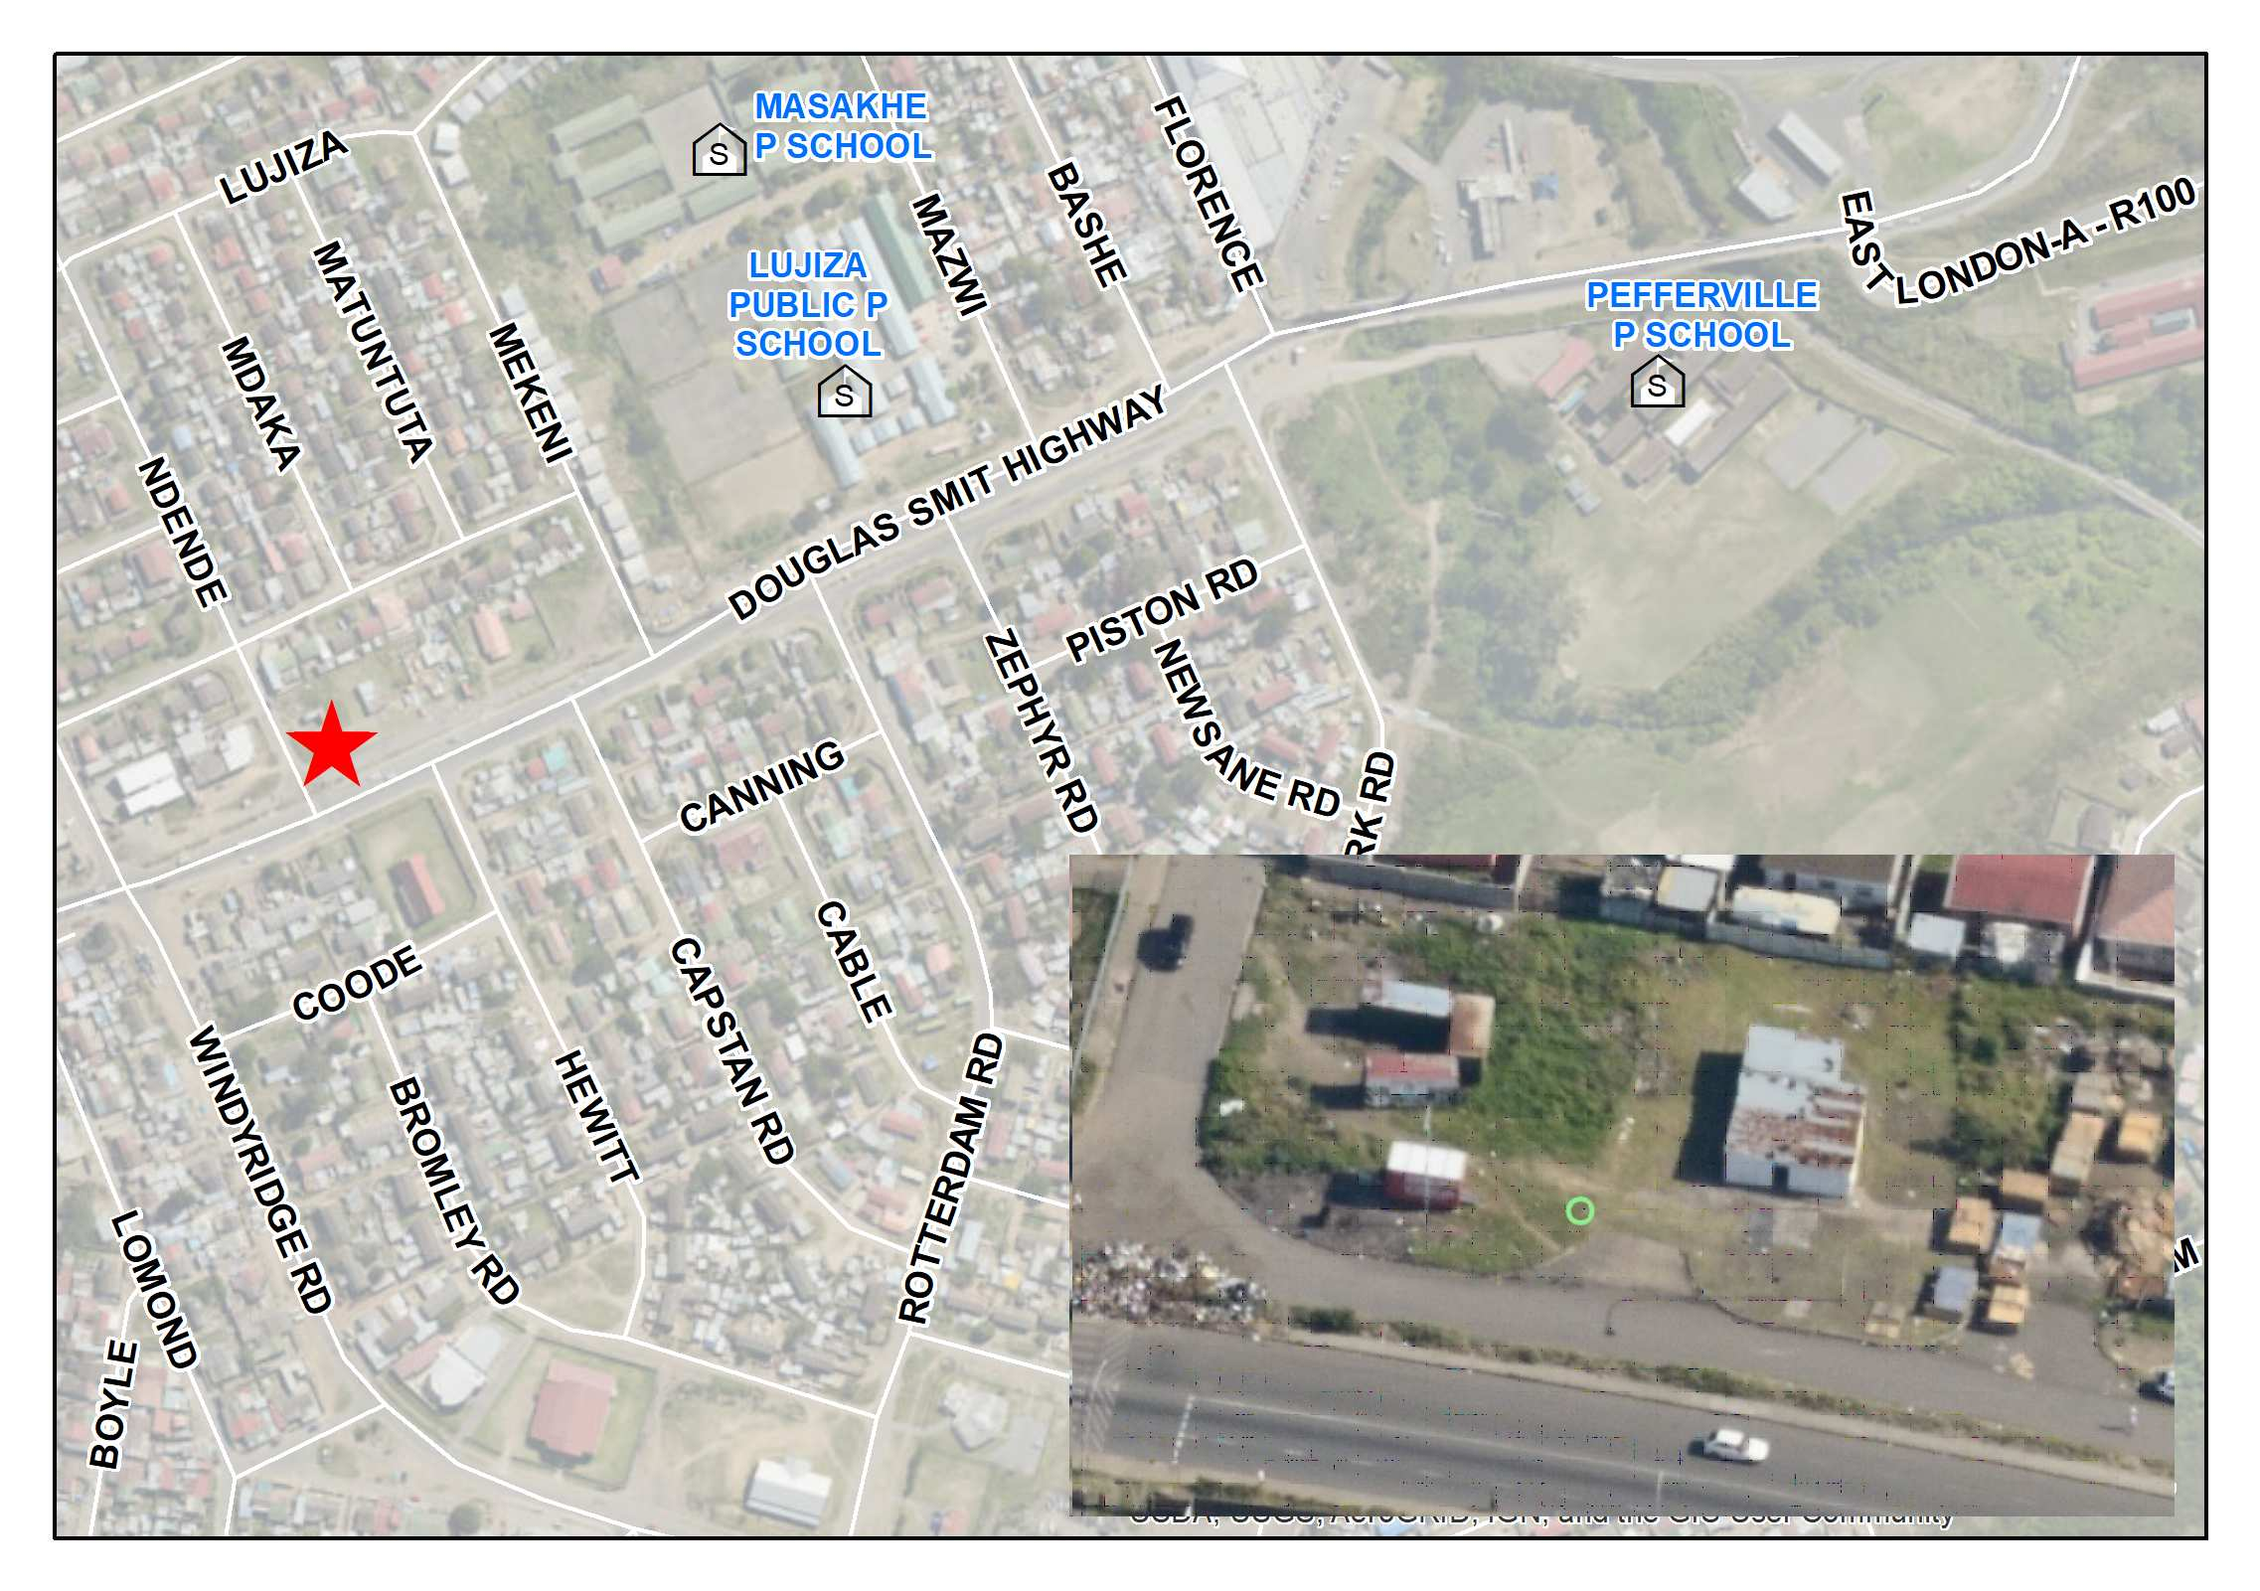
Duncan Village Collection site on Douglas Smith Highway next to Boxer.

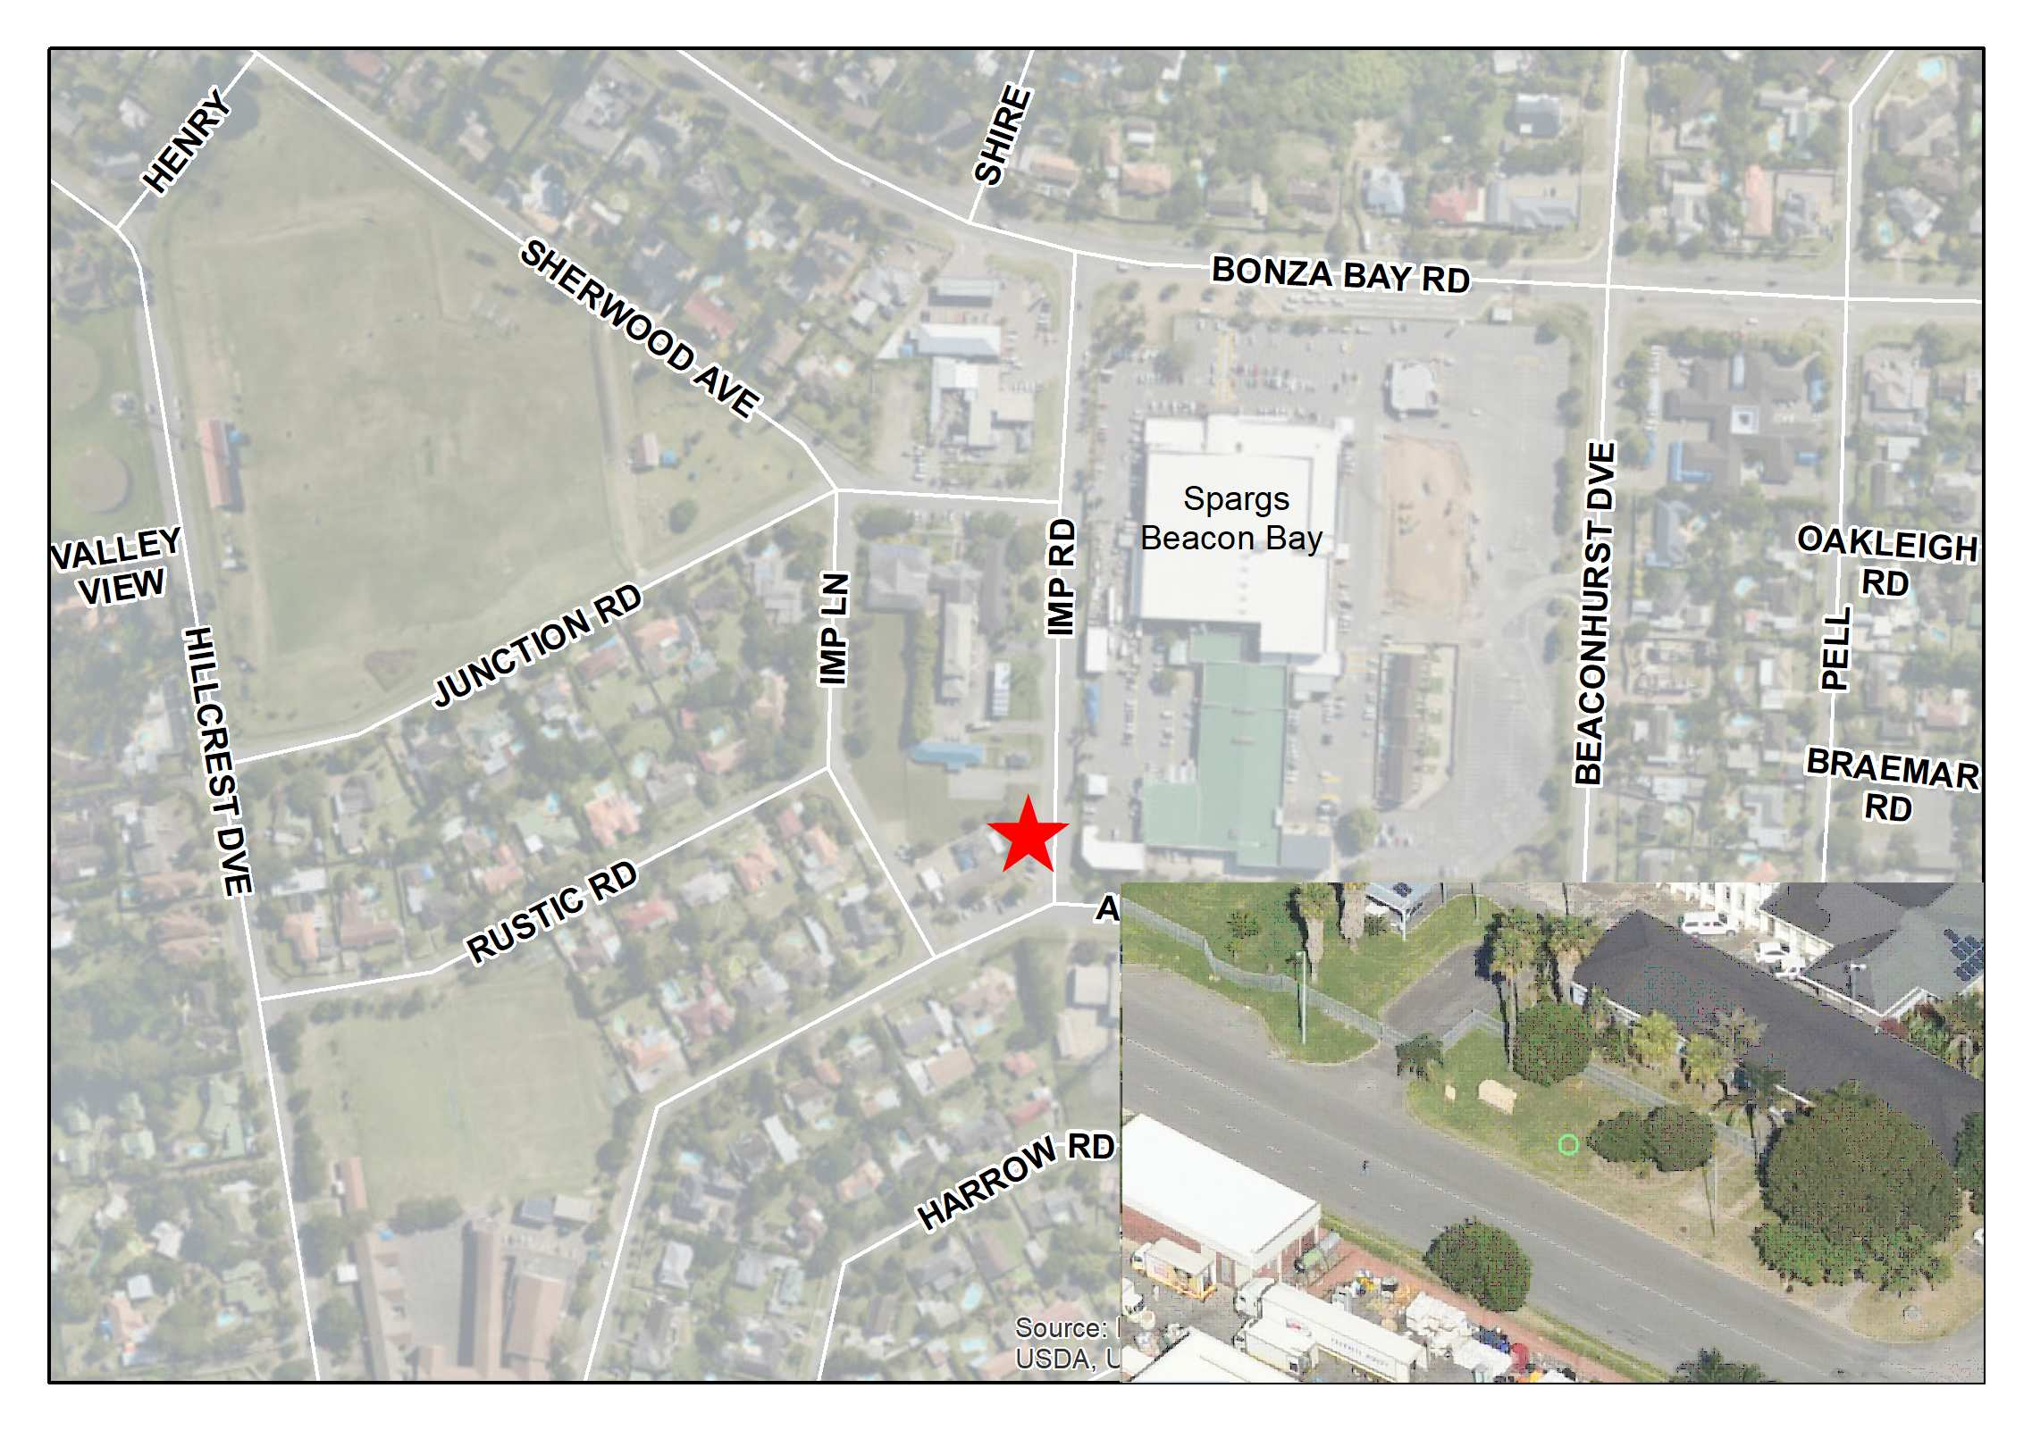
Beacon Bay collection site opposite Spargs Supermarket

Project partners - contact information

Project manager/coordinator at the Swedish EPA:
Project coordinator for the Swedish EPA:
Name: Lotten Sjölander
Institution: Swedish Environmental Protection Agency/ Unit for International Cooperation
Address: S-106 48 Stockholm, Sweden
Tel: + 46 – 10 6981507, Fax: +46-8-698 10 99
E-mail: lotten.sjolander@swedishepa.se

Project manager for the Swedish EPA:
Name: Nina Avdagic Lam
Institution: Swedish Environmental Protection Agency
Address: S-106 48 Stockholm, Sweden
Tel: + 46- 10 698 00 00, Fax: +46-8-698 10 99
E-mail: nina.avdagic-lam@swedishepa.se

Counterpart (in partner country):
Name: Mr Crystal Baloyi
Institution: Department of Environmental, Forestry and Fisheries
Address: 474 Steve Biko Street, Arcadia, South Africa
Tel: (+27) 12 399 9774
E-mail: cbaloyi@environment.gov.za

Name: Sharon Mogomotsi
Institution: Department of Environmental, Forestry and Fisheries
Address: 474 Steve Biko Street, Arcadia, South Africa
Tel: (+27) 12 399 9767
E-mail: smogomotsi@environment.gov.za

Name: Nomphelo Daniel
Institution: Buffalo City Metropolitan Municipality
Address: Office of the GM: Attic Building, North End; East London 5200; Eastern Cape
Tel: +27828416291
E-mail: nomphelod@buffalocity.gov.za

Name: Nokuzola Shweni
Institution: Buffalo City Metropolitan Municipality
Address: Office of the GM: Solid Waste, Attic Building, North End,East London 5200; Eastern Cape
Tel: +27682807619
E-mail: nokuzolas@buffalocity.gov.za

Name: Per-Olof Hallberg (Project Manager)
Institution: Gästrike Atervinnare
Address: Utmarksvagen 16, 80291, Gävle, Sweden.
Tel: +46702652604
E-mail: per-olof.hallberg@gastrikeatervinnare.se

Name: Marvin Morrings
Institution: Gästrike Återvinnare
Address: Utmarksvägen 16, 80291, Gävle, Sweden.
Tel: +46701675118
E-mail: marvin_hugo.morrings@gastrikeatervinnare.se

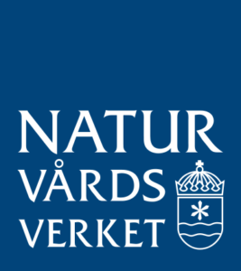

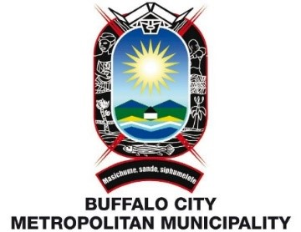
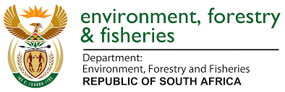
Dept of Environment, Forestry & Fisheries Swedish Environment
Protection Agency

