REPORT TO EXECUTIVE MAYOR: 25 JANUARY 2015
File No.:5/1/1/1[14/15]
Author: CITY MANAGER (ANDILE FANI)/VP

2014/15 MID-YEAR BUDGET AND PERFORMANCE ASSESSMENT REPORT

- PURPOSE
The purpose of the report is for the Executive Mayor to consider and note the mid-year budget and performance assessment of Buffalo City Metropolitan Municipality for the 2014/15 financial year.

- AUTHORITY
Executive Mayor

- LEGAL / STATUTORY REQUIREMENTS
The Constitution of the Republic of South Africa, 1996
Municipal Finance Management Act No 56, 2003 Chapter 7, Section 71
Municipal Budget and Reporting Regulations

- BACKGROUND
In terms of Section 72, of the Municipal Finance Management Act No. 56, 2003, Chapter 8, the accounting officer of the municipality must, by 25 January of each year, submit a mid-year performance assessment report of the municipality to the mayor of the municipality.

In terms of the Section 54 (1), (2) and (3) of the Municipal Finance Management Act No. 56, 2003 Chapter 7, the following applies: -
“(1) on receipt of a statement or report submitted by the accounting officer of the Municipality
In terms of section 54 (1), the mayor must –
- consider the statement or report;
- check whether the municipality’s approved budget is implemented in accordance with the service delivery and budget implementation plan;
- consider and ,if necessary make any revisions to the service delivery and budget implementation plan, provided that revisions to the service delivery targets and performance indicators in the plan may only be made with the approval of the council following approval of an adjustment budget;
- issue any appropriate instructions to the accounting officer to ensure –
  - that the budget is implemented in accordance with the service delivery and budget implementation plan; and
  - that spending of funds and revenue collection proceed in accordance with the budget;
- Identify any financial problems facing the municipality , including any emerging or impending financial problems ; and
- In the case of a section 72 report , submit the report to the council
by 31 January of each year.

In terms of the Section 52 (d) of the Municipal Finance Management Act No. 56, 2003 Chapter 7, “the Mayor of the municipality must, within 30 days of the end of each quarter, submit a report to the Council on the implementation of the budget and the financial state affairs of the municipality”.

According to the Municipal Budget Reporting and Regulations (MBRR), 2009, “A mid-year budget and performance assessment of a municipality referred to in section 72 of the Act must be in the format specified in Schedule C and include all the required tables, charts and explanatory information taking into account any guidelines issued by the Minister in terms of of S168(1) of the Act” (MFMA).

This report responds to the above sections of MFMA and follows the legislative requirements of the Municipal Budget and Reporting Regulations (Schedule C format).
TABLE OF CONTENTS

REPORT TO COUNCIL: 28 JANUARY 2015 1
1. PURPOSE 1
2. AUTHORITY 1
3. LEGAL / STATUTORY REQUIREMENTS 1
4. BACKGROUND 1
LIST OF TABLES 4
PART 1: IN-YEAR REPORT 6
5. EXECUTIVE MAYOR’S REPORT/COMMENTS 7
6. RESOLUTIONS 8
7. EXECUTIVE SUMMARY ON THE IMPLEMENTATION OF THE BUDGET AND THE FINANCIAL STATE OF AFFAIRS OF THE MUNICIPALITY FOR THE PERIOD ENDING 31 DECEMBER 2014 9
8. IN-YEAR BUDGET STATEMENT MAIN TABLES 12
PART 2: SUPPORTING DOCUMENTATION 24
9. IN-YEAR BUDGET STATEMENT SUPPORTING TABLES AND DOCUMENTATION 25
10. DEBTORS 25
11. CREDITORS’ ANALYSIS 30
12. INVESTMENT PORTFOLIO ANALYSIS 32
13. ALLOCATION AND GRANT RECEIPTS AND EXPENDITURE 35
14. COUNCILLOR AND EMPLOYEE BENEFITS 42
15. SERVICE DELIVERS AND BUDGET IMPLEMENTATION PLAN PERFORMANCE AND MATERIAL VARIANCES 50
17. PARENT MUNICIPAL FINANCIAL PERFORMANCE 56
18. CAPITAL PROGRAMME PERFORMANCE 57
19. OTHER SUPPORTING DOCUMENTS 62
ANNEXURES: 71

LIST OF TABLES

Table 1: Performance Summary 9
Table 2:C1: Monthly Budget Statement Summary 12
Table 3: C2: Monthly Budget Statement – Financial Performance (standard classification 13
Table 4: C3: Monthly Budget Statement – Financial Performance (Revenue and expenditure by municipal vote) 14
Table 5: C4: Monthly Budget Statement – Financial Performance (Revenue by Source and Expenditure by Type) 15
Table 6: Repairs and Maintenance per Directorate 20
Table 7: C5: Monthly Budget Statement – Capital Expenditure (municipal vote, standard classification and funding) 21
Table 8: C6: Monthly Budget Statement – Financial Position 22
Table 9: C7: Monthly Budget Statement – Cash Flow 23
Table 10: SC3 Monthly budget statement Aged Debtors 25
Table 11: Debtor’s Age Analysis by Income Source Comparison 26
Table 12: Age Analysis per Category Type 27
Table 13: Cumulative Nett Billing, Receipts and Debtors Collection Ratio per month from 2013/14 to 2014/15 financial year 28
Table 14: Analysis of Government Debtors 29
Table 15: SC4 Monthly budget Statement Aged Creditors 30
Table 16: Payments made to the 20 highest Paid Creditors – December 2014 31
Table 17: SC5 Monthly budget Statement – investment portfolio 32
Table 18: SC6 Monthly budget Statement – transfers and grants receipts 35
Table 19: SC7 (1) Monthly budget Statement – transfers and grants expenditure 36
Table 20: SC7 (2) Monthly budget Statement – expenditure against approved rollovers 37
Table 21: Spending per Conditional Grant Funding Allocation 38
Table 22: SC8 Monthly Budget Statement – Councilor and Staff Benefits 42
Table 23: Overtime per Directorate 43
Table 24: Overtime Per Cost Centre: October 2014 – December 2014 44
Table 25: Standby & Shift Allowance per Directorate 48
Table 26: Temporary Staff Per Directorate 49
Table 27: Councillors Costs 50
Table 28: SC1: Material Variance Explanations for Revenue By Source and Expenditure by Type 53
Table 29: SC9: Monthly Budget Statement – Actuals and Revised Targets for Cash Receipts 54
Table 30: SC2: Monthly Budget Statement Performance Indicators 56
Table 31: Capital Expenditure per Funding Source against Budget 57
Table 32: Actual Expenditure per Service against Budget 58
Table 33: Actual Expenditure per Directorate against Budget 59
Table 34: SC12 Monthly budget Statement – capital expenditure trend 59
Table 35: SC13a Monthly budget Statement – capital expenditure on new assets by asset class 60
Table 36: SC13b Monthly budget Statement – capital expenditure on renewal of existing assets by asset class 61
Table 37: Operating Projects per Directorate 62
Table 38: Operating Projects per Funding Source 63
Table 39: Health & Public Safety – Cost Analysis 64
Table 40: Community Services – Cost Analysis 65
Table 41: SC13c Monthly budget Statement – repairs and maintenance by asset class 66
Table 42: SC13d Monthly budget Statement – depreciation by asset class 67

PART 1: IN-YEAR REPORT

- EXECUTIVE MAYOR’S REPORT/COMMENTS
In terms of the legislative requirements placed on myself as an Executive Mayor , in terms of S54 (1):
- I have considered the report and found it to be a fair reflection of the financial affairs of the institution.
- The approved budget has been implemented in accordance with the service delivery and budget implementation plan.
- There are currently no changes to the service delivery and budget implementation plan; however the changes will be considered during the mid-year adjustment budget period.
- The monthly budget statements (S71 reports) are prepared by the Accounting Officer and submitted to the office of the Executive Mayor within 10 working days of the new month.
- The S71 reports for the first six months of this financial year have been considered in the preparation of this assessment report.
- In terms of the mid-year performance report the city finds itself in a healthy financial state of affairs.
- RESOLUTIONS
It is recommended that:

- Executive Mayor considers and notes the 2014/15 Mid-Year Budget and Performance Assessment Report of BCMM for the 2013/14 Financial Year in terms of Section 72 of the MFMA including supporting documentation attached as Annexure A to F.

- Executive Mayor notes the financial state of affairs of the Municipality as reflected in this report and take note of the year to date collection rate for the period ending 31 December 2013 of 92% and the twelve (12) months average which is also 92% for the 12 months ending 31 December 2014.

- Executive Mayor notes the spending rate on DoRA allocation conditional grants, capital projects and operating projects, as well as reasons and remedial actions for such as indicated in section 13, 18 and 19 respectively of this report.

………………………….. ………………………
A. FANI DATE
CITY MANAGER

- EXECUTIVE SUMMARY ON THE IMPLEMENTATION OF THE BUDGET AND THE FINANCIAL STATE OF AFFAIRS OF THE MUNICIPALITY FOR THE PERIOD ENDING 31 DECEMBER 2014

  - Dashboard / Performance Summary
Table 1: Performance Summary
OVERALL OPERATING RESULTS |  |  | CASH MANAGEMENT
Income |  | R 2,648,725,785 | Bank Balance |  | R 110,375,210
Expenditure |  | R 2,376,699,134 | Call investment deposits |  | R 2,346,288,572
Operating Surplus |  | R 272,026,651 | Cash and cash equivalents |  | R 2,456,663,782
 |  |  | Total value of investments |  | R 2,356,444,798
 |  |  | Total investments - own funds |  | R 1,740,301,734
 |  |  | Total grants |  | R 616,143,064
 |  |  | Total Loans |  | R 576,865,525
DEBTORS |  |  | SURPLUS PER SERVICE
Total debtors book |  | R 1,330,478,144 | Water |  | R 50,631,758
Total debtors - Government |  | R 39,508,048 | Electricity |  | R 68,245,027
Total debtors - Business |  | R 264,901,823 | Refuse |  | R 31,307,025
Total debtors - Households |  | R 871,913,793 | Sewerage |  | R 19,836,126
Total debtors - Other |  | R 154,154,480
Total debt written off |  | R 1,413,811
CAPITAL EXPENDITURE |  |  | OPERATING PROJECTS EXPENDITURE
2013/2014: Capital Expenditure as a % of Adjusted Budget of R975.10 million:  Exp.(exc vat)=R261.72 mil  % expenditure (Excl.vat): 27%  Exp.(Incl vat)=R289.80 mil  % expenditure (Incl vat):30% | 2014/2015: Capital Expenditure as a % of Adjusted Budget of R1,06 billion:  Exp. (Excl.vat)=R363.83 mil  % exp (Excl. vat) :34%  Exp. (Incl.vat)=R397.76 mil  % exp (Incl. vat) :38% |  | 2013/2014: Operating Expenditure as a % of Adjusted Budget of R345.45 million:  Exp.(exc vat)=R89.66 mil  % expenditure (Excl.vat): 26%  Exp.(Incl. vat)=R89.75 mil  % exp. (Incl.vat)= 26% | 2013/2014: Operating Expenditure as a % of Adjusted Budget of R288.44 million:  Exp.(exc vat)=R113.64  % exp.(Excl.vat)= 39%  Exp.(Incl. vat)=R114.10  % exp.(Incl.vat)= 40%
FINANCIAL |  |  | HUMAN RESOURCES
Operating Surplus for the period |  | R272,026,651 | Total staff complement |  | 4,554
12 months average collection ratio |  | 92% | Staff Appointments |  | 423
YTD Grants and subsidies |  | R 554,514,595 | Staff Terminations |  | 136
Debtors to Revenue |  | 15.77% | Total overtime paid (YTD) |  | R 48,391,923
Percentage of Creditors paid within terms |  | 100% | Allowances and benefits- Councilors |  | R 22,654,269
Current ratio |  | 3.50:1 | Salary bill - Officials |  | R 584,063,714
Total debt to Total assets |  | 4.12% | Workforce costs as a % of income |  | 22.1%
Capital Charges to Operating Expenditure |  | 16.22%

  - Liquidity position
Buffalo City Metropolitan Municipality’s liquidity is considered relatively sound as the Current Ratio is 3.50:1 which indicates the ability of Municipality’s current assets to cover its current liabilities. Debtors constitute 23% of the current assets, inventory constitutes 2% and cash & cash equivalents comprise 75% of the current assets.

  - Collection Rate and Outstanding Debtors
The debtor’s collection rate for the average twelve months ending 31 December 2014 is 92% (2013/14: 89.85%) and the year to date collection rate for the six (6) months is also 92% (2013/14: 92.91%).

Total debtors book as at 31 December 2014 amounts to R1,33 billion (2013: R1.07 billion). Households: R871.91 million, Business: R264.90 million, Government: R39.51 million, Other: R154.15 million. The ratio of debtors to revenue is 15.77%. The debtors’ age analysis report is reflected on Annexure B – SC3.

  - Capital Expenditure
BCMM has spent 38% (R397.76 million, inclusive of reclaimed vat) of its 2014/15 adjusted capital budget of R1.06 billion as at 31 December 2014. This reflects an improvement when compared to the same period in the previous financial year where 30% (R289 million) of the adjusted capital budget of R975.10 million was spent. (Refer to Section 15 for further details)

A detailed schedule of the capital projects expenditure is outlined in Annexure E.

  - Operating projects
The Metro has spent 40% (R114.10 million, inclusive of reclaimed vat) of its 2014/15 adjustment budget of R288.44 million as at 31 December 2014. This reflects an improvement when compared to the same period in the previous financial year where 26% (R89.75 million) of the adjusted operating projects budget of R345.45 was spent.

A detailed schedule of the operating projects expenditure is outlined in Annexure D.

  - Expenditure on DoRA Current Allocation
The Metro has spent 43% (R304.89 million, inclusive of reclaimed vat) of its 2014/2015 DoRA allocation of R714.18 million.This reflects an improvement when compared to the same period in the previous financial year where 32% (R268.31 million) of the adjusted budget of R836.82 was spent . (Refer to Section 11 for further details)

    - Urban Settlement Development Grant (USDG) funded projects
BCMM has spent 41% (R278.19 million, inclusive of reclaimed vat) of its 2014/15 USDG budget of R673.29 million as at 31 December 2014. This reflects an improvement when compared to the same period in the previous financial year where 32% (R254.89 million) of the adjusted budget of R790.18 million.(Refer to Section 11 for further details)

  - Cash and Cash Equivalents
The cash and cash equivalents of the City as at 31 December 2014 are R2.46 billion made up of cash and bank amounting to R110.38 million and call investment deposits of R2.35 billion. This funding is invested with various financial institutions in compliance with the MFMA. Refer to Section 7.8 and Annexure A – C7 for the cash flow statement as well as Section 10 and Annexure B – SC5 for the investment portfolio breakdown.

  - Outstanding Creditors
The Metro is paying its creditors within 30 days as stipulated by the MFMA.Refer to Section 9 for details.

  - Long-Term Debt Profile
The total long term borrowings of the municipality as at 31 December 2014 amounts to R576.87 million (Refer to Annexure C for the schedule of borrowings).

The ratio of total debt to total assets is 4.12% and the total debt to revenue ratio is 14.73% as at 31 December 2014.

- IN-YEAR BUDGET STATEMENT MAIN TABLES

  - Monthly Budget Statement Summary
The table below provides a high-level summation of the Metro’s financial performance, capital expenditure, financial position, cash flow, debtors and creditors analysis.

Table 2:C1: Monthly Budget Statement Summary
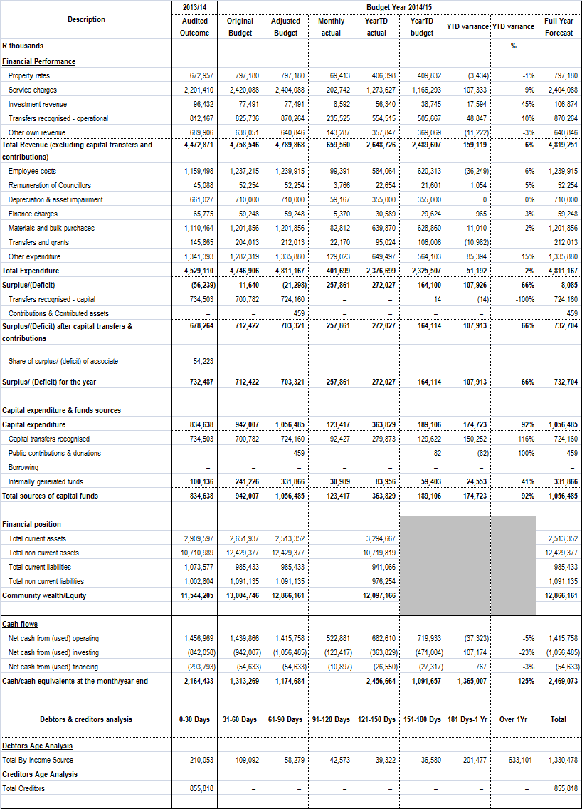
  - Monthly Budget Statement – Financial Performance (standard classification)
The table below is an overview of the budgeted financial performance in relation to revenue and expenditure per standard classification.

Table 3: C2: Monthly Budget Statement – Financial Performance (standard classification
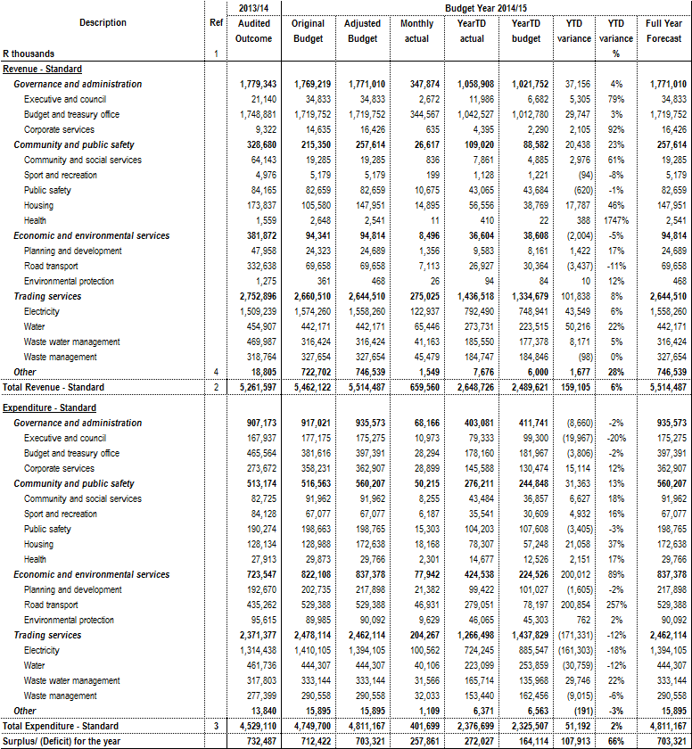

  - Monthly Budget Statement – Financial Performance (Revenue and expenditure by municipal vote)

The table below shows budgeted financial performance in relation to the revenue and expenditure by vote as well as the operating surplus or deficit for the City.

Table 4: C3: Monthly Budget Statement – Financial Performance (Revenue and expenditure by municipal vote)
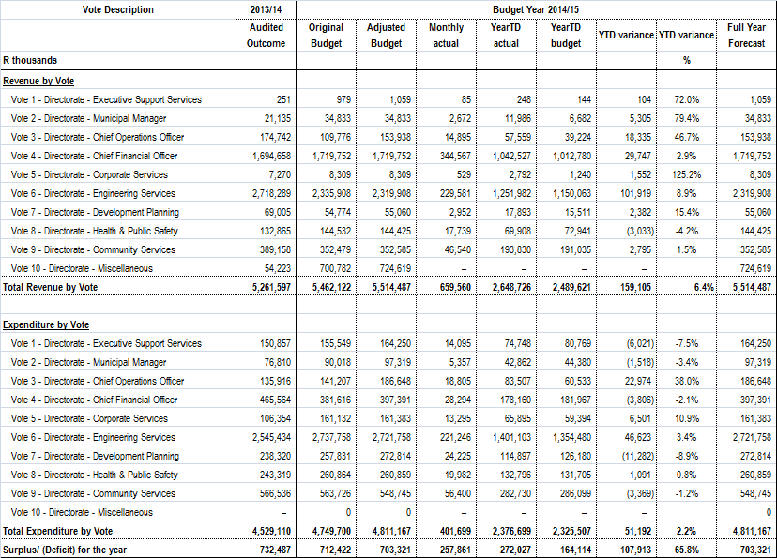

  - Monthly Budget Statement – Financial Performance (Revenue by Source and Expenditure by Type)
The statement of financial performance presented in table below, compares the expenditure and revenue on accrual basis against budget for the period ending 31 December 2014.

Table 5: C4: Monthly Budget Statement – Financial Performance (Revenue by Source and Expenditure by Type)
Description | 2013/14 | Budget Year 2014/15
Description | Audited Outcome | Original Budget | Adjusted Budget | Monthly actual | YearTD actual | YearTD budget | YTD variance | YTD variance | Full Year Forecast
R thousands |  |  |  |  |  |  |  | %
Revenue By Source
Property rates | 672,059 | 796,668 | 796,668 | 69,413 | 406,398 | 409,386 | (2,988) | -1% | 796,668
Property rates - penalties & collection charges | 898 | 512 | 512 | – | – | 447 | (447) | -100% | 512
Service charges - electricity revenue | 1,383,884 | 1,511,514 | 1,495,514 | 107,072 | 747,318 | 709,396 | 37,922 | 5% | 1,495,514
Service charges - water revenue | 325,360 | 370,613 | 370,613 | 44,658 | 224,793 | 181,861 | 42,932 | 24% | 370,613
Service charges - sanitation revenue | 230,786 | 271,995 | 271,995 | 27,421 | 155,164 | 133,388 | 21,776 | 16% | 271,995
Service charges - refuse revenue | 228,895 | 251,704 | 251,704 | 21,966 | 131,456 | 125,852 | 5,604 | 4% | 251,704
Service charges - other | 32,485 | 14,261 | 14,261 | 1,625 | 14,895 | 15,797 | (901) | -6% | 14,261
Rental of facilities and equipment | 15,018 | 17,013 | 17,013 | 889 | 5,975 | 5,009 | 967 | 19% | 17,013
Interest earned - external investments | 96,432 | 77,491 | 77,491 | 8,592 | 56,340 | 38,745 | 17,594 | 45% | 77,491
Interest earned - outstanding debtors | 27,178 | 29,383 | 29,383 | 3,005 | 16,573 | 14,692 | 1,881 | 13% | 29,383
Dividends received | – | – | – | – | – | – | – |  | –
Fines | 5,910 | 9,400 | 9,400 | 260 | 2,033 | 2,837 | (804) | -28% | 9,400
Licences and permits | 14,161 | 20,523 | 20,523 | 936 | 6,870 | 7,029 | (159) | -2% | 20,523
Agency services |  | – | – | – |  | – | – |  | –
Transfers recognised - operational | 812,167 | 825,736 | 870,264 | 235,525 | 554,515 | 505,667 | 48,847 | 10% | 870,264
Other revenue | 626,920 | 561,732 | 564,527 | 138,197 | 326,395 | 339,502 | (13,107) | -4% | 564,527
Gains on disposal of PPE | 720 |  | – | – | – | – | – |  | –
Total Revenue (excluding capital transfers and contributions) | 4,472,871 | 4,758,546 | 4,789,868 | 659,560 | 2,648,726 | 2,489,607 | 159,119 | 6% | 4,789,868
Expenditure By Type
Employee related costs | 1,159,498 | 1,237,215 | 1,239,915 | 99,391 | 584,064 | 620,313 | (36,249) | -6% | 1,239,915
Remuneration of councillors | 45,088 | 52,254 | 52,254 | 3,766 | 22,654 | 21,601 | 1,054 | 5% | 52,254
Debt impairment | 241,011 | 203,074 | 187,074 | 16,923 | 101,537 | 93,537 | 8,000 | 9% | 187,074
Depreciation & asset impairment | 661,027 | 710,000 | 710,000 | 59,167 | 355,000 | 355,000 | 0 | 0% | 710,000
Finance charges | 65,775 | 59,248 | 59,248 | 5,370 | 30,589 | 29,624 | 965 | 3% | 59,248
Bulk purchases | 1,110,464 | 1,201,856 | 1,201,856 | 82,812 | 639,870 | 628,860 | 11,010 | 2% | 1,201,856
Other materials |  | – | – | – | – | – | – |  | –
Contracted services | 9,743 | 19,909 | 19,909 | 2,768 | 8,631 | 9,955 | (1,324) | -13% | 19,909
Transfers and grants | 145,865 | 204,013 | 212,013 | 22,170 | 95,024 | 106,006 | (10,982) | -10% | 212,013
Other expenditure | 1,078,878 | 1,059,336 | 1,128,897 | 109,332 | 539,329 | 564,449 | (25,119) | -4% | 1,128,897
Loss on disposal of PPE | 11,761 |  | – | – |  | – | – |  | –
Total Expenditure | 4,529,110 | 4,746,906 | 4,811,167 | 401,699 | 2,376,699 | 2,429,344 | (52,645) | -2% | 4,811,167
Surplus/(Deficit) | (56,239) | 11,640 | (21,298) | 257,861 | 272,027 | 60,263 | 211,764 | 0 | (21,298)
Transfers recognised - capital | 734,503 | 700,782 | 724,160 | – | – | 14 | (14) | (0) | 724,160
Contributions recognised - capital |  |  | 459 |  |  | – | – |  | 459
Contributed assets |  |  |  |  |  | – | –
Surplus/(Deficit) after capital transfers & contributions | 678,264 | 712,422 | 703,321 | 257,861 | 272,027 | 60,277 |  |  | 703,321
Taxation |  |  |  |  |  |  | –
Surplus/(Deficit) after taxation | 678,264 | 712,422 | 703,321 | 257,861 | 272,027 | 60,277 |  |  | 703,321
Attributable to minorities
Surplus/(Deficit) attributable to municipality | 678,264 | 712,422 | 703,321 | 257,861 | 272,027 | 60,277 |  |  | 703,321
Share of surplus/ (deficit) of associate | 54,223
Surplus/ (Deficit) for the year | 732,487 | 712,422 | 703,321 | 257,861 | 272,027 | 60,277 |  |  | 703,321

    - ANALYSIS OF STATEMENT OF FINANCIAL PERFOMANCE
      - Property rates – Penalties and collection charges
This relates to the flat rate charged on certain properties leased by the municipality. This revenue varies according to the number of such properties leased during the year.

      - Service charges-Water revenue
The over-recovery of 24% is a combination of the non-alignment of the period budget with the actual trend of consumption and the influences of seasonal consumption trends.

      - Service charges-Sanitation revenue
The over-recovery of 16% is a combination of the non-alignment of the period budget with the actual trend of consumption.

      - Rental of facilities and equipment
Rental of facilities is demand driven and therefore difficult to predict accurately. The situation is monitored on a monthly basis.

      - Interest earned –External investments
The variance of 45% is due to interest earned on unspent grants invested than what was projected during the 2013/14 budget preparation process.The spending rate on condition grants has however improved significantly.

      - Interest earned –Outstanding debtors
The variance of 13% on the interest earned on outstanding debtors signifies that
during the six month period July 2014 -December 2014, the amount owed by
debtors has been more than what was expected.

      - Fines
The under-recovery on fines is mostly due to non-payment of traffic fines, withdrawing of drunken driving cases by the Prosecuters, cases struck of the roll by the magistrates and cases withdrawn by the courts. The city has however obtained the Licence plate recognition system to facilitate the collection of outstanding fines.

      - Other revenue
Other revenue is made up of numerous miscellaneous items (e.g. town planning fees, market income, vehicle registration fees, cemetery fees, grave space sales, tender receipts, towing fees, etc). The situation is monitored on a monthly basis.

      - Contracted services
Contracted services are utilised as an when required. As the year progresses the use of contracted services will stabilise.

      - Transfers and grants
These transfers and grants are paid at predetermined intervals according to the existing contractual agreements. These payments are therefore not made at a constant rate throughout the year.

      - Other expenditure
Other expenditure includes operating projects, general expenses as well as repairs and maintenance.Expenditure on repairs and maintenance is provided in table 6 below.

Table 6: Repairs and Maintenance per Directorate
 | 2014/2015 | 2014/2015 |  | 2014/2015
Directorate | Annual | Annual | 2014/2015 | % of
 | Budget | Expenditure | Variance | Budget
 | R | R | R | %
Directorate of Executive Support | 2,645,438 | 168,761 | 2,476,677 | 6%
Directorate of The Municipal Manager | 72,820 | 2,828 | 69,992 | 4%
Directorate of Chief Operations Officer | 83,651 | 40,445 | 43,206 | 48%
Directorate of Finance | 2,699,709 | 735,944 | 1,963,765 | 27%
Directorate of Corporate Services | 5,462,300 | 4,049,062 | 1,413,238 | 74%
Directorate of Engineering Services | 260,749,491 | 139,723,034 | 121,026,457 | 54%
Electricity | 111,151,194 | 46,313,671 | 64,837,523 | 42%
Water | 37,061,324 | 15,992,615 | 21,068,709 | 43%
Sanitation | 25,286,865 | 9,570,789 | 15,716,076 | 38%
Other | 87,250,108 | 67,845,958 | 19,404,150 | 78%
Directorate of Development Planning | 24,650,498 | 3,865,826 | 20,784,672 | 16%
Directorate of Health and Public Safety | 5,706,795 | 1,031,809 | 4,674,986 | 18%
Directorate of Community Services | 27,678,109 | 10,567,556 | 17,110,553 | 38%
TOTAL | 329,748,811 | 160,185,266 | 169,563,545 | 49%

  - Capital Expenditure (municipal vote, standard classification and funding)
The table below reflects the Metro’s capital programme in relation to capital expenditure by municipal vote, capital expenditure by standard classification and funding sources required to fund the capital budget, including information on capital transfers from National and Provincial departments.
Table 7: C5: Monthly Budget Statement – Capital Expenditure (municipal vote, standard classification and funding)
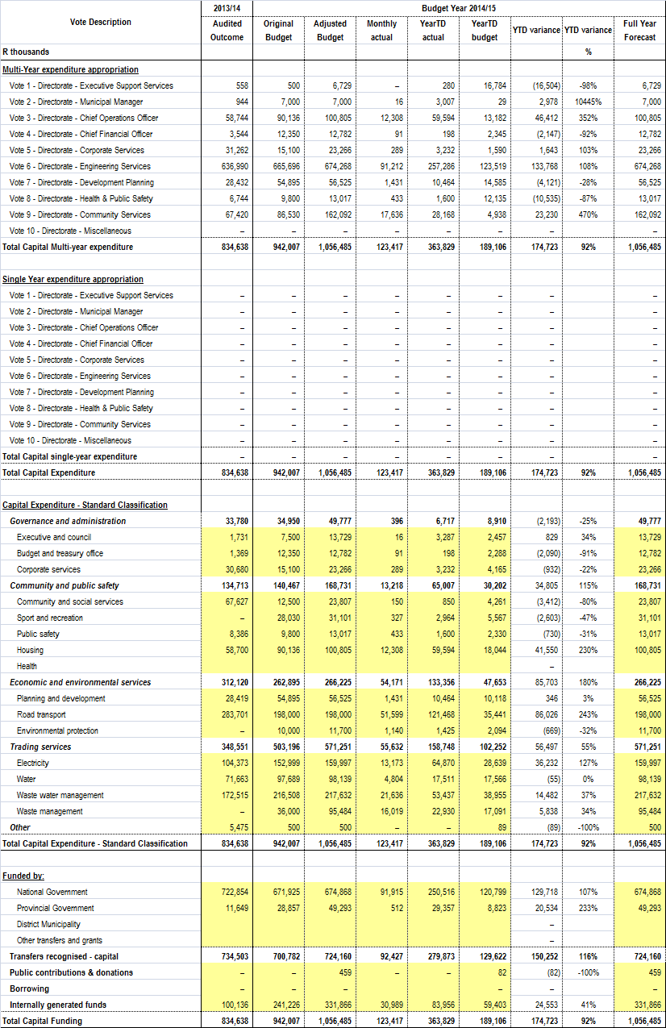
  - Monthly Budget Statement – Financial Position
The table below reflects the financial position of the Metro. It is good to note that the Metro is having high assets over liabilities resulting into the net worth of R12.1 billion.

Table 8: C6: Monthly Budget Statement – Financial Position

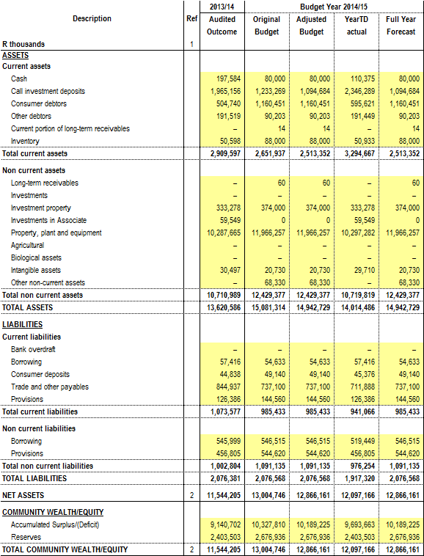
  - Monthly Budget Statement – Cash Flow
The Metros’ cash flow position and cash/cash equivalent outcome is shown in the table below. The Metro’s cash posision reflect a net increase of R292 million resulting in cash and cash equivalent closing balance of R2.46 billion as at 31 December 2014.

Table 9: C7: Monthly Budget Statement – Cash Flow
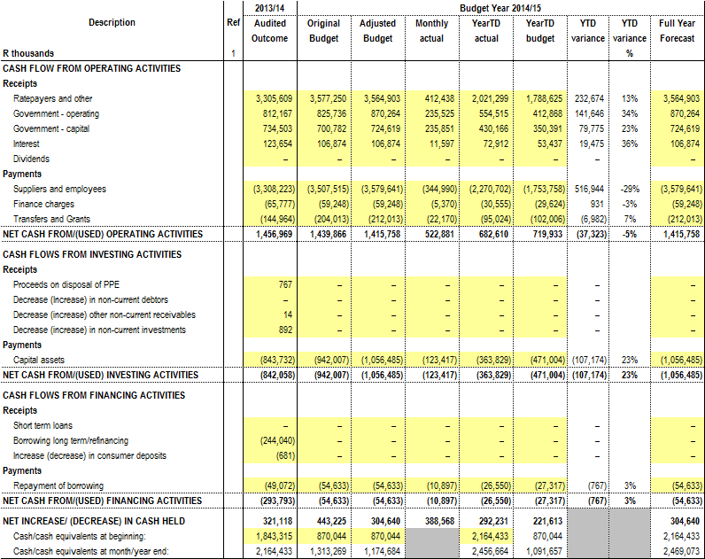

PART 2: SUPPORTING DOCUMENTATION

- IN-YEAR BUDGET STATEMENT SUPPORTING TABLES AND DOCUMENTATION
Part one (1) of the report covered the Executive Mayor’s report/comments, resolutions, executive summary and in-year budget statement tables. This part (part two) if the report covers the supporting documentation.

- DEBTORS

The debtor analysis table below (table 10) provides an age analysis summary by revenue source and customer category for the total debtors.

Table 10: SC3 Monthly budget statement Aged Debtors
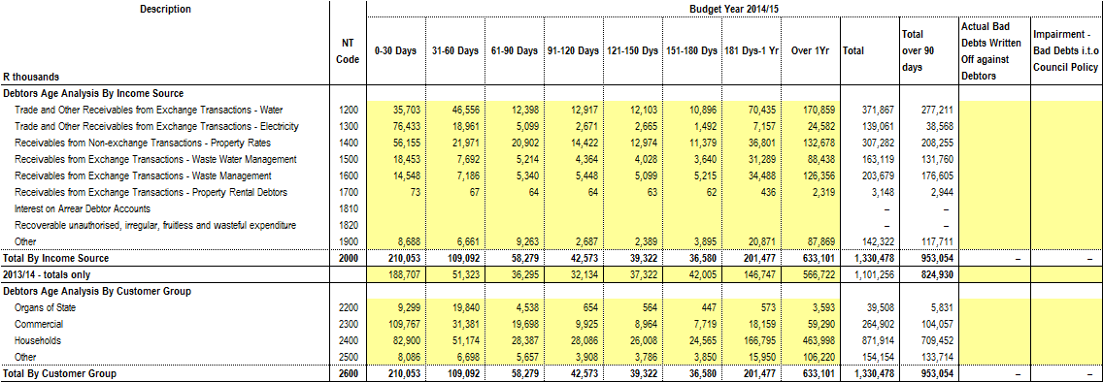

The debtors that are older than 30 days , which includes all charges, amounted to R1,120,425,540 at 31 December 2014 which is an increase of R57,639,236 over the amount of R1,062,786,304 at 30 Novemeber 2014.The primary reason for the increase relates to debtors who fail to settle their current accounts by the due date and therefore the debt ages into 30 days. No collection action can be taken prior to the due date. Furthermore, the instability of the network, especially in the inland and midland areas has had a negative impact on credit control actions which had to be limited due to the network problems.The IT department is working on ensuring reliable network availability to all BCMM sites.

  - Additional debtor’s information.
    - Age Analysis per Category

Table 11 below details debtors age analysis that are older than 30 days by income source as at 31 December 2014. It also provides comparison with the prior year (31 December 2013) which indicate an increase from R863 million to 1.120 billion.

Table 11: Debtor’s Age Analysis by Income Source Comparison
AGEING | RATES | SEWERAGE | ELECTRICITY | WATER | REFUSE | SUNDRY  DEBTORS | TOTAL FOR  DECEMBER 2014 | TOTAL FOR  DECEMBER 2013
30 DAYS | 21,970,561 | 7,691,897 | 18,960,865 | 46,555,819 | 7,185,654 | 6,727,693 | 109,092,489 | 56,918,512
60 DAYS | 20,901,999 | 5,214,430 | 5,099,126 | 12,397,880 | 5,339,784 | 9,326,228 | 58,279,447 | 37,141,172
90 DAYS | 14,421,917 | 4,363,638 | 2,670,988 | 12,917,412 | 5,447,714 | 2,751,305 | 42,572,974 | 46,231,207
120 DAYS  TO 360 DAYS | 61,154,238 | 38,957,906 | 11,314,469 | 93,434,592 | 44,801,721 | 27,716,349 | 277,379,275 | 201,791,013
YEAR 2 | 39,160,265 | 27,733,413 | 9,062,403 | 59,077,523 | 36,247,568 | 25,781,451 | 197,062,624 | 148,524,516
YEAR 3 | 26,042,991 | 16,606,926 | 6,383,444 | 32,163,919 | 22,509,731 | 16,400,135 | 120,107,146 | 92,555,609
YEAR 4 | 19,890,569 | 10,573,979 | 3,701,525 | 19,031,061 | 13,859,312 | 11,555,033 | 78,611,478 | 65,808,529
YEAR 5 | 12,344,829 | 7,308,030 | 1,773,337 | 15,664,170 | 11,860,420 | 8,799,664 | 57,750,451 | 68,226,269
YEAR 5+ | 35,239,733 | 26,215,860 | 3,661,347 | 44,922,519 | 41,878,878 | 27,651,320 | 179,569,657 | 146,119,477
TOTAL | 251,127,102 | 144,666,079 | 62,627,505 | 336,164,895 | 189,130,781 | 136,709,178 | 1,120,425,540 | 863,316,303

    - Age Analysis per Category
Table 12 below details debtors age analysis per category type that are older than 30 days as at 31 December 2014. It also reflects the percentage split per catergory with domestic consumers having the highest share followed by indigent consumers.

Table 12: Age Analysis per Category Type
CATEGORY TYPE | 30 DAYS | 60 DAYS | 90 DAYS | 120 DAYS+ | Total | % Share
Domestic | 33,286,208 | 18,353,977 | 15,093,327 | 431,936,526 | 498,670,037 | 44.51
Indigent | 17,633,263 | 9,914,623 | 12,912,474 | 248,765,298 | 289,225,659 | 25.81
Business | 31,380,688 | 19,697,777 | 9,925,147 | 94,131,466 | 155,135,078 | 13.85
Government | 19,840,007 | 4,537,639 | 654,215 | 5,176,996 | 30,208,857 | 2.70
MunicIpal Staff | 240,979 | 111,218 | 78,540 | 639,654 | 1,070,391 | 0.10
Councillors | 13,415 | 7,483 | 1,247 | 25,122 | 47,266 | 0.00
Other | 6,697,930 | 5,656,730 | 3,908,024 | 129,805,568 | 146,068,252 | 13.04
Total | 109,092,489 | 58,279,447 | 42,572,974 | 910,480,630 | 1,120,425,540 | 100.00
Note*: A stop order deduction is implemented for all municipal staff and councillors in arrears. When new staff join the employ of the municipality in many instances there is services debt, and therefore the arrears will be liquidated over an acceptable period of time, in terms of the Credit Control Policy. The reason why the debt reflects in the 30/60/90 day columns relating to staff and councillors is due to the fact that when the stop orders are receipted the payment is allocated to the oldest ageing category, giving the impression that current is not being paid, which is not the case as an amount is being deducted for current accounts.
    - Billing, Receipts and Debtors Collection Rate
Table 13 below reflect the twelve monthly amounts billed, collected/received and collection rate for the current financial year and previous financial year.

Table 13: Cumulative Nett Billing, Receipts and Debtors Collection Ratio per month from 2013/14 to 2014/15 financial year
Month | 2013/2014 |  |  | 2014/2015
 | Billing | Receipts | Collection Rate | Billing | Receipts | Collection Rate
July | 2,325,509,002 | -2,153,249,916 | 92.59 | 2,602,264,135 | -2,371,903,619 | 91.00
August | 2,360,722,274 | -2,184,105,932 | 92.52 | 2,568,699,884 | -2,383,877,074 | 93.00
September | 2,362,100,818 | -2,201,573,537 | 93.20 | 2,589,585,746 | -2,403,569,317 | 93.00
October | 2,390,760,330 | -2,214,093,193 | 92.61 | 2,625,227,643 | -2,450,270,791 | 93
November | 2,413,236,105 | -2,237,227,839 | 92.71 | 2,652,206,738 | -2,440,158,405 | 92
December | 2,451,423,493 | -2,277,540,737 | 92.91 | 2,662,628,366 | -2,446,012,486 | 92
January | 2,473,521,774 | -2,288,389,311 | 92.52
February | 2,489,423,294 | -2,286,023,845 | 91.83
March | 2,508,588,241 | -2,317,244,720 | 92.37
April | 2,533,810,040 | -2,313,671,267 | 91.31
May | 2,563,282,383 | -2,324,079,609 | 90.67
June | 2,565,798,810 | -2,350,536,518 | 91.61

    - Government Accounts
The total arrears owed by Government Departments to Buffalo City Metropolitan Municipality as at 31 December 2014 amounted to R30,208,857.

Arrears as at 31 December 2014 R30,208,857
Arrears as at 30 November 2014 R18,866,004
Increase R11,342,853

The main reason for the increase in the arrears is due to accounts that were billed incorrectly and for which credit adjustments are being processed. A total payment of R15,087,344.11was received from Government Departments in December 2014.The breakdown of the arrears per department is indicated in the table hereunder, as at 31 Decembr 2014. Accounts that are in credit are excluded. Credit Control action is implemented to recover all outstanding debtors.

Table 14: Analysis of Government Debtors
DEPARTMENT | PROPERTY RATES | SERVICES | ARREARS AS AT  31 DECEMBER 2014 | ARREARS AS AT  30 NOVEMBER 2014 | DIFFERENCE
National Department Of Public Works | 4,861,553 | 919,628 | 5,781,182 | 8,421,877 | (2,640,696)
Provincial Department Of Public Works | 1,646,219 | 17,305,831 | 18,952,050 | 5,294,314 | 13,657,736
Department Of Education |  | 2,015,914 | 2,015,914 | 3,344,595 | (1,328,680)
Department Of Health |  | 2,975,797 | 2,975,797 | 1,356,988 | 1,618,808
Department Of Social Development |  | 129,803 | 129,803 | 42,320 | 87,483
Department Of Transport |  | - | - | - | -
Department Of Agriculture |  | 120,233 | 120,233 | 91,210 | 29,024
Department Of Nature Conservation |  | 701 | 701 | - | 701
Department of Community Development |  | 853 | 853 | 78,295 | (77,441)
Sport, Recreation, Arts and Culture |  | - | - | 34,252 | (34,252)
Unemployment Insurance |  | 130,649 | 130,649 | 127,574 | 3,075
Members Of Provincial Legislature |  | 84,833 | 84,833 | 66,159 | 18,674
Department of Water Affairs |  | 16,842 | 16,842 | 8,421 | 8,421
TOTAL | 6,507,772 | 23,701,085 | 30,208,857 | 18,866,004 | 11,342,853

- CREDITORS’ ANALYSIS
The creditors’ analysis as depicted in table 15 below contains an aged analysis by customer type.

Table 15: SC4 Monthly budget Statement Aged Creditors

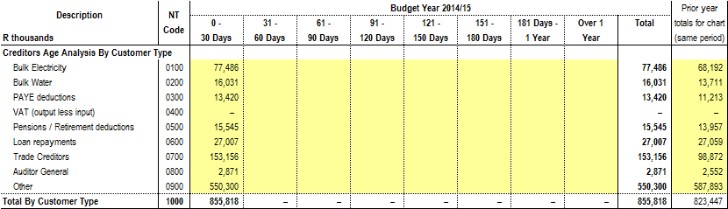

The table below (table 16) depics actual payments made by BCMM to its top twenty (20) creditors in December 2014.
Table 16: Payments made to the 20 highest Paid Creditors – December 2014
CREDITOR | 90 DAYS | 60 DAYS | 30 DAYS | LESS THAN 30 DAYS | TOTAL | PAYMENT
ESKOM |  |  |  | 77,486,249.78 | 77,486,249.78 | 77,486,249.78
AMATOLA WATER |  |  |  | 16,031,281.00 | 16,031,281.00 | 16,031,281.00
RONNIES MOTORS TRUST |  |  | 14,347,043.09 |  | 14,347,043.09 | 14,347,043.09
MANTELLA TRADING 522CC |  |  |  | 7,884,596.08 | 7,884,596.08 | 7,884,596.08
LUQAQAMBO CIVILS CONSTRUCTION CC |  |  |  | 5,514,941.59 | 5,514,941.59 | 5,514,941.59
MAKINWA MEDIA MANAGEMENT |  |  |  | 4,984,986.48 | 4,984,986.48 | 4,984,986.48
EYA BANTU PROFFESSIONAL SERVICES CC |  |  |  | 4,621,253.95 | 4,621,253.95 | 4,621,253.95
LIFETIME CONNECTION MANUFACTURING SUPPLY CC |  |  |  | 4,374,645.19 | 4,374,645.19 | 4,374,645.19
C & M FASTENERS CC |  |  |  | 3,602,254.30 | 3,602,254.30 | 3,602,254.30
SIYASEBENZA TARRING & CONSTRUCTION CC |  |  |  | 3,431,318.38 | 3,431,318.38 | 3,431,318.38
SHONE'S ELECTRICAL |  |  |  | 3,349,985.92 | 3,349,985.92 | 3,349,985.92
MASIQHAME TRADING 520 CC |  |  |  | 3,166,650.69 | 3,166,650.69 | 3,166,650.69
MTIMA PLUMBING SERVICES |  |  |  | 3,082,702.71 | 3,082,702.71 | 3,082,702.71
UKUZI DEVELOPERS (PTY) LTD |  |  |  | 3,009,600.00 | 3,009,600.00 | 3,009,600.00
MVEZO JV ELITYENI |  |  |  | 2,958,585.81 | 2,958,585.81 | 2,958,585.81
RENNIES TRAVEL (PTY) LTD |  |  | 2,793,993.57 |  | 2,793,993.57 | 2,793,993.57
KADA GENERAL TRADING |  |  |  | 2,602,568.13 | 2,602,568.13 | 2,602,568.13
SOYAMA CONSTRUCTION SERVICES CC |  |  |  | 2,554,485.00 | 2,554,485.00 | 2,554,485.00
ELECTRICAL MOULDED COMPONENTS |  |  |  | 2,371,143.00 | 2,371,143.00 | 2,371,143.00
ESRI SOUUTH AFRICA |  |  |  | 2,297,760.06 | 2,297,760.06 | 2,297,760.06
TOTAL |  |  | 17,141,036.66 | 153,325,008.07 | 170,466,044.73 | 170,466,044.73
- INVESTMENT PORTFOLIO ANALYSIS
The investment portfolio analysis detailed in table 17 below includes information of the institution where funds are invested, period of investment, type of investment and accrued interest for the month.
Table 17: SC5 Monthly budget Statement – investment portfolio
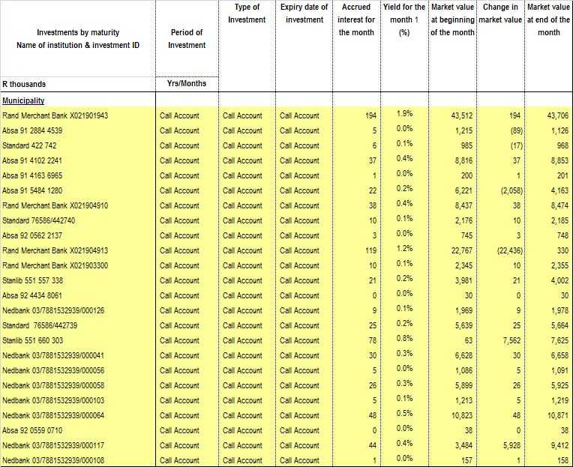
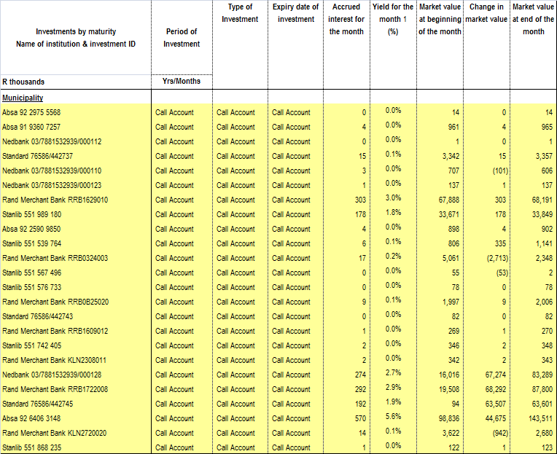
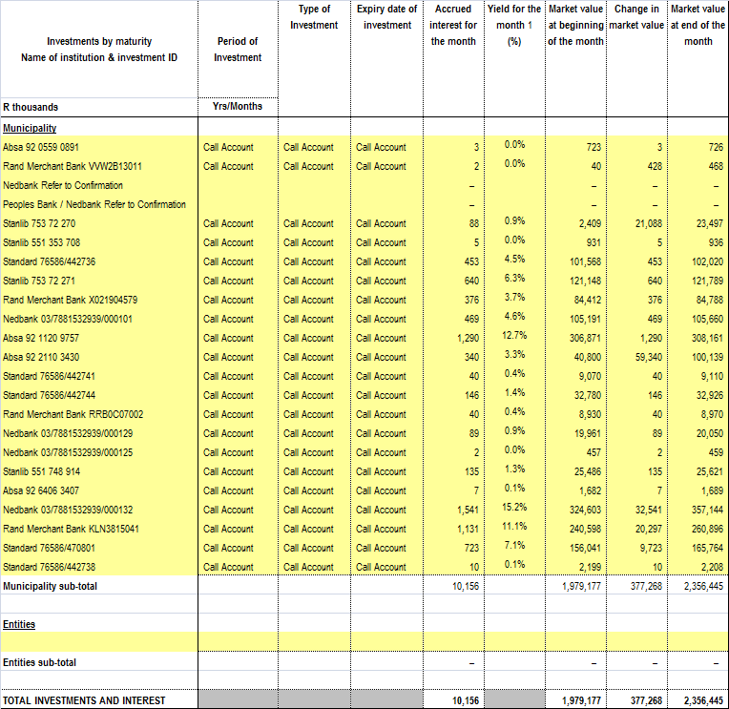
- ALLOCATION AND GRANT RECEIPTS AND EXPENDITURE
Transfers and grants expenditure per allocation or grant is provided in the table below.

Table 18: SC6 Monthly budget Statement – transfers and grants receipts
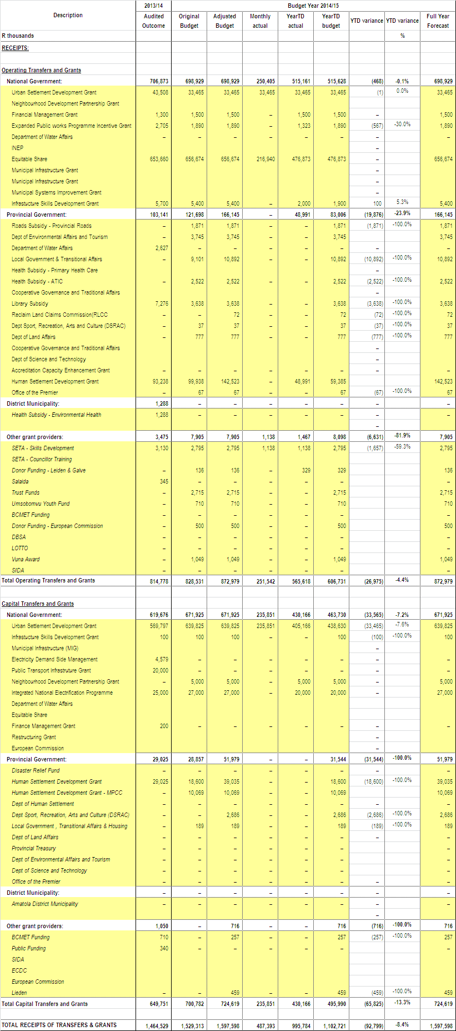

Transfers and grants expenditure per grant allocation are provided in the tables below (table 19: current allocation; table 20 approved rollovers. Futher details on grants expenditure performance is detailed in section 12.1 below.

Table 19: SC7 (1) Monthly budget Statement – transfers and grants expenditure
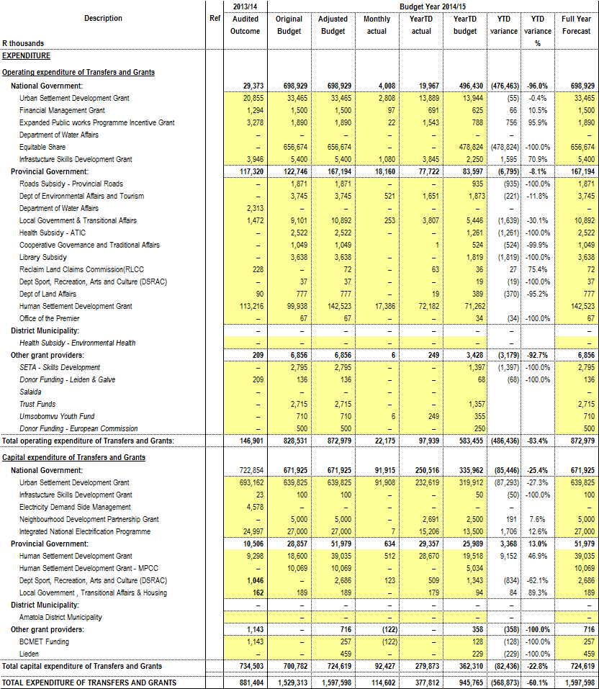

Table 20: SC7 (2) Monthly budget Statement – expenditure against approved rollovers
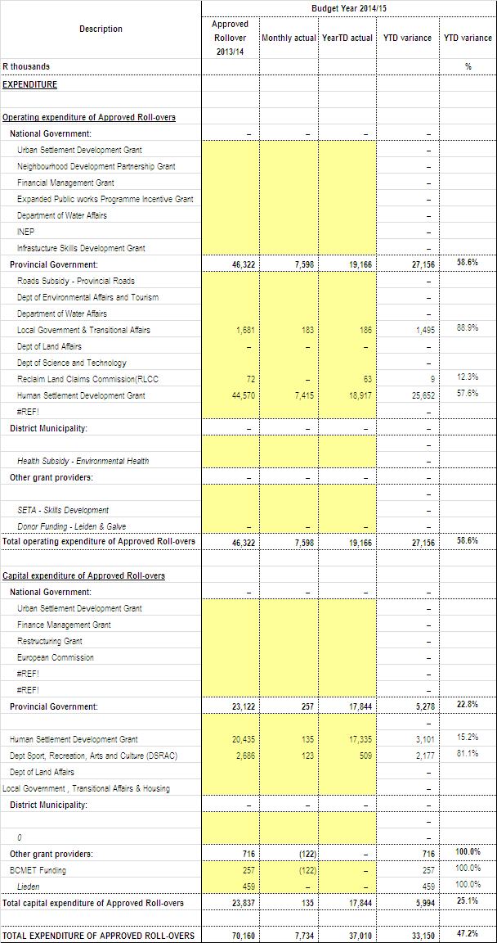

  - Expenditure On Conditional Grant Allocations
The total expenditure inclusive of reclaimed vat on conditional grants DoRA allocation as at 31 December 2014 amounts to R304.89 million which is 43% of the adjusted budget of R714.18 million.

Table 21 below reflects the year to date expenditure on 2014/15 total conditional grants.

Table 21: Spending per Conditional Grant Funding Allocation
Funding/Grant | 2014/2015 Approved Budget | YTD Expenditure | Variance | % Exp vs. Budget
DoE(Integrated National Electrification Programme) | 27 000 000 | 17 330 019 | 9 669 981 | 64%
Finance Management Grant | 1 500 000 | 694 238 | 805 762 | 46%
Infrastructure Skills Development Grant | 5 500 000 | 4 057 260 | 1 442 740 | 74%
Urban Settlement Development Grant | 673 289 000 | 278 192 843 | 395 096 157 | 41%
Neighbourhood Development Partnership | 5 000 000 | 3 067 921 | 1 932 079 | 61%
Expanded Public Works Programme | 1 890 000 | 1 543 090 | 346 910 | 82%
TOTAL | 714 179 000 | 304 885 371 | 409 293 629 | 43%

    - INTERGRATED NATIONAL ELECTRIFICATION PROGRAMME (INEP)
The project is progressing well. BCMM has spent 64% of its allocation for this grant.

    - FINANCE MANAGEMENT GRANT (FMG)
The expenditure percentage for FMG is 46%.The funding will be fully spent before year end on implementation of Standard Chart of Accounts (SCOA), training of municipal officials in financial management and remuneration of interns.

    - INFRASTRUCTURE SKILLS DEVELOPMENT GRANT (ISDG)
The project is progressing well and will meet the target for full utilisation of funds at year end. Currently the expenditure is sitting at 74%.

    - URBAN SETTLEMENT DEVELOPMENT GRANT (USDG)
HOUSING

Reasons for the Low Expenditure
Technical timeframe delays in appointment of service providers and finalisation of contractual documents for projects at procurement stage contributed to low expenditure. Furthermore bad weather conditions affected positive progress on projects that are under implementation. With regards to planning projects, designs will be finalised within the third quarter of the financial year (Amalinda Co - Op, Ilitha North and DVRI Pilot - Competition Site).

Corrective Measures to improve expenditure
The department has finalised the contractual documents and obligations with the newly appointed service providers, the service providers have commenced with project implementation. The department has further planned to advance project monitoring in order to ensure that the service providers deliver as per required milestones. Subsequent to the efforts, the process of procurement of annual contractors and consultant has been followed seeking to overcome procurement turnaround. Overall expenditure has improved and should continuously increase as all service providers are busy with execution of work. The department has further planned to advance project monitoring in order to ensure that the service providers deliver as per required milestones.

ENGINEERING SERVICES
Reasons for the Low Expenditure
Water and Sanitation Capital Projects
Some of the Treatment Works projects have been delayed due to litigations, and another project is delayed due to bidders not meeting the minimum functionality requirement.

DEVELOPMENT PLANNING & ECONOMIC DEVELOPMENT
Reasons for the Low Expenditure
Over-commitment of Service Providers delayed the work and as a result some of the projects did not start as scheduled.

Corrective Measures to improve expenditure
Service Providers have provided programmes on how they will fast track implementation of the projects.

HEALTH AND PUBLIC SAFETY
Reasons for the Low Expenditure
Design plans had to be drawn up by the service provider prior to commencement of work on the KWT Traffic building.

Corrective Measures to improve expenditure
A meeting was held on 12 December 2014 with the service provider, Acting Director of Health & Public Safety and Architects Branch to provisionally agreed to the amendments that are to be made to the draft plans. Service provider is to amend plans and resubmit for final approval.

COMMUNITY SERVICES
Enterprise Project Management Office (EPMO) is assisting the amenities department with project implementation in order to speed up the processes. Annual contracts are also being used where possible.

The process of land acquisition is a challenge that delayed the construction of transfer station sites, as a result the department has resorted to sourcing a service provider to provide and manage the transfer station for garden waste and builder’s rubble. A tender has been advertised for a service provider that will both provide and operate a site.

    - NEIGHBOURHOOD DEVELOPMENT PARTNERSHIP GRANT (NDPG)
BCMM has spent 61% of its allocation for the Neighbourhood Development Partnership Grant Programme grant. The programme is progressing well.

    - EXPANDED PUBLIC WORKS PROGRAMME (EPWP)
BCMM has spent 82% of its allocation for the Expanded Public Works Programme. The programme is progressing well.

- COUNCILLOR AND EMPLOYEE BENEFITS
  - Councillor and Employees Benefits Summary

Table 22 below provides summary of employees and Councilors remuneration.

Table 22: SC8 Monthly Budget Statement – Councilor and Staff Benefits

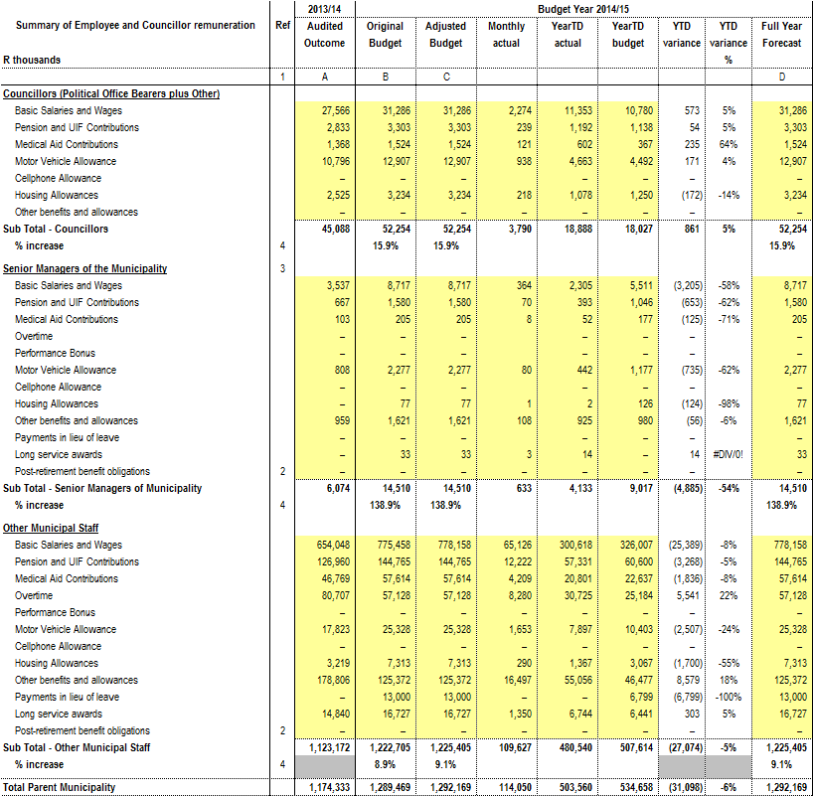

  - Overtime Analysis
Table 23 below provides comparison of overtime expenditure against budget per directorate for the period ended 31 December 2014. Table 24 below details over expenditure incurred per cost centre for the past three months ended 31 December 2014. The municipality has overspent on its year to date overtime budget as at 31 December 2014, reasons for over expenditure are stated in section 13.2.1 below.

Table 23: Overtime per Directorate
 | 2014/2015 | 2014/2015 | 2014/2015 | 2014/2015 | 2014/2015
Directorate | Annual | YTD | YTD | Variance | % of YTD
 | Budget | Budget | Expenditure |  | Budget
 | R | R | R | R | %
Directorate of Executive Support Services | 1,378,035 | 689,018 | 2,413,861 | (1,724,844) | 350%
Directorate of The Municipal Manager | 265,184 | 132,592 | 284,202 | (151,610) | 214%
Directorate of Chief Operations Officer | 91,062 | 45,531 | 88,860 | (43,329) | 195%
Directorate of Financial Service | 1,170,142 | 585,071 | 489,954 | 95,117 | 84%
Directorate of Corporate Services | 523,517 | 261,759 | 267,428 | (5,670) | 102%
Directorate of Engineering Services | 14,355,233 | 7,177,617 | 13,604,775 | (6,427,159) | 190%
Electricity | 6,742,973 | 3,371,487 | 3,859,602 | (488,115) | 114%
Water | 2,617,693 | 1,308,847 | 5,098,462 | (3,789,615) | 390%
Sanitation | 4,031,868 | 2,015,934 | 4,209,956 | (2,194,022) | 209%
Other | 962,699 | 481,350 | 436,756 | 44,594 | 91%
Directorate of Development Planning | 901,209 | 450,605 | 340,084 | 110,520 | 75%
Directorate of Health and Public Safety | 21,784,059 | 10,892,030 | 9,598,095 | 1,293,934 | 88%
Directorate of Community Services | 16,659,651 | 8,329,826 | 21,304,663 | (12,974,838) | 256%
Total | 57,128,092 | 28,564,046 | 48,391,923 | (19,827,877) | 169%

Table 24: Overtime Per Cost Centre: October 2014 – December 2014
 |  | October 2014 Amount | November 2014 Amount | December 2014 Amount
 | Directorate -Executive Support Services
105 005 | Office of The Director of Executive Support | 360 826.53 | 329 534.11 | 333 943.93
105 020 | Public Participation & Ward Committees | 27 196.16 | 28 747.58 | 7 390.74
105 025 | Strategic Support | 8 932.61 | 946.71 | 1 104.50
105 030 | Special Programmes | 6 961.57 | 637.68 | 1 819.55
110 005 | IDP | - | - | 5 278.54
120 010 | Public Relations & International Events | 67 611.89 | 83 560.11 | 77 153.71
 |  | 471 528.76 | 443 426.19 | 426 690.97
 | Directorate - Municipal Manager
205 005 | Office of The Municipal Manager & Support Services | 53 652.17 | 50 138.80 | 50 302.50
215 005 | Internal Audit | - | 1 673.03 | -
225 010 | Municipal Public Accounts Committee | - | 2 020.80 | 3 789.00
 |  | 53 652.17 | 53 832.63 | 54 091.50
 | Directorate - Chief Operations Officer
250 005 | Office of the Chief Operations Officer | - | 35 973.76 | 11 103.00
255 005 | Housing Department | 3 261.60 | 307.8 | 1 447.65
 |  | 3 261.60 | 36 281.56 | 12 550.65
 | Directorate - Chief Financial Officer
305 010 | Support Services Office | 11 434.25 | - | 11 792.42
315 005 | Budget Office | 8 574.50 | - | 7 171.40
320 005 | Asset Risk & Financial Services | - | 1 000.09 | -
320 010 | Supply Chain Management | 17 469.25 | 864.14 | 22 418.84
320 015 | Expenditure Office | 6 503.76 | 6 859.38 | 1 146.88
320 020 | Salary Office | - | - | 9,105.10
330 010 | Consolidated Billing & Miscellaneous Revenue Office | 15 471.07 | 68 668.64 | 82 945.55
330 015 | Debtors Management Office | 11 097.30 | 14 528.60 | 10 657.74
330 020 | Customer Care Office | 24 720.43 | 27 978.58 | 19 192.86
 |  | 95 270.56 | 119 899.43 | 164 430.79
 | Directorate - Corporate Services
405 005 | Office of The Director of Corporate Services | - | 1 194.40 | -
415 005 | Administrative & Council Support | 2 657.51 | 10 155.83 | 1 477.02
415 010 | Auxilliary & Telecommunication Services | 24 948.61 | 23 161.81 | 25 595.32
415 025 | Management Information Services | 4 605.26 | 12 197.60 | 10 768.93
420 005 | H.R. Administration | 20 111.87 | - | -
420 010 | Occupational Risk Management | 4 961.60 | -4 961.60 | 9 923.20
420 015 | Labour Relations | 1 680.14 | - | -
425 005 | Research Policy & Knowledge Management Unit | 11 602.49 | - | 5 319.26
 |  | 70 567.48 | 41 748.04 | 53 083.73
 |  | October 2014 Amount | November 2014 Amount | December 2014 Amount
 | Directorate - Engineering Services
505 005 | Office of The Director of Engineering Services - Admin | 9 952.09 | 2 384.40 | 2 145.96
505 010 | City Engineering Building | 1 471.28 | 1 275.11 | 1 667.45
505 015 | Chiselhurst, Beacon Bay & Kwt Depot | 18 598.32 | 34 335.36 | 23 367.12
510 005 | Scientific Services | - | 1 843.99 | -
515 006 | Night Soil Removal - Coastal | 164 976.89 | 63 023.78 | 85 977.36
515 007 | Night Soil Removal - Central |  | 2 796.17 | 1 922.36
515 010 | Sewerage Admin | 13 249.00 | - | -
515 026 | Sewerage Treatment - Coastal | 42 807.74 | 36 597.98 | 43 001.88
515 027 | Sewerage Treatment - Central | 43 169.42 | 37 889.30 | 25 848.34
515 028 | Sewerage Treatment - Inland | 55 615.77 | 155 903.87 | 100 005.98
515 031 | Sewerage Reticulation - Coastal | 323 188.12 | 182 022.15 | 190 302.65
515 032 | Sewerage Reticulation - Central | 244 051.87 | 86 804.45 | 100 396.99
515 033 | Sewerage Reticulation - Inland | 103 017.22 | 107 864.84 | 91 244.34
520 005 | Water Administration | 8 845.61 | 2 550.15 | 9 094.04
520 011 | Maden Dam | 12 971.70 | 356.82 | 26 770.96
520 012 | Bridle Drift Dam | 6 779.88 | 2 565.36 | -
520 015 | Bulk Pumping Stations | 20 663.88 | 12 116.91 | 26 089.62
520 021 | Umzonyana Water Treatment Works | 43 632.81 | 55 191.32 | 72 166.50
520,023 | KWT Water Treatment Works | 99 478.57 | 58 699.66 | 130 983.40
520 024 | Mdantsane Bulk Pumping | 54 846.56 | 30 835.14 | 15 013.44
520 025 | Water Ops & Maint. - Inland | 160 987.25 | 176 606.06 | 254 467.56
520 026 | Water Ops & Maint. - Midland | 194 340.67 | 197 070.36 | 198 623.85
520 030 | Water Ops & Maint. - Coastal | 249 995.51 | 238 195.09 | 260 907.95
525 005 | Construction Distribution | 2 433.48 | 4 866.96 | -
525 010 | Roads Administration | 908.48 | - | 908.48
525 025 | Roads & Stormwater Drainage | 523.12 | 23 591.17 | 21 589.66
525 040 | Project Management Unit | - | 360 | -
530 010 | Fleet Management - Westbank | 769.5 | - | 1 539.00
530 015 | Mechanical Workshop - Braelyn | 26 078.39 | 25 249.57 | 32 537.48
530 020 | Fleet Management - Braelyn | - | - | 3,831.60
535 005 | Electricity Administration | 1 933.30 | 1 753.07 | 1 933.29
535 010 | Electricity Distribution Supervisory Staff | 606 537.97 | 536 475.43 | 782 996.66
535 025 | Electricity Planning & Design | 688.13 | 720.89 | 524.28
535 040 | Revenue Protection | 59 186.82 | 69 172.67 | 88 986.69
 |  | 2 571 699.35 | 2 149 118.03 | 2 594 844.89

 |  | October 2014 Amount | November 2014 Amount | December 2014 Amount
 | Directorate - Development Planning
615 095 | Building Maintenance - Coastal / Central | 9 851.91 | 7 939.80 | 45 018.69
620 015 | Traffic Signal Maintenance | 8 146.12 | - | 20 553.77
625 005 | Buffalo City Bus Services | 22 391.62 | 7 386.15 | 11 388.72
635 005 | Local Economic Development | - | - | 6 148.12
635 010 | Market | 16 621.59 | 23 002.74 | 41 600.87
 |  | 57 011.24 | 38 328.69 | 121 975.63
 | Directorate - Health & Public Safety
705 010 | Support Services | - | 1 167.84 | -
710 030 | Environmental Health | 17 803.12 | 5 130.47 | 8 955.59
725 005 | Public Safety Administration |  | 7 153.20 | -
725 010 | Fire & Rescue Services | 225 679.55 | 170 744.85 | 369 138.79
725 015 | Law Enforcement Services | 758 465.42 | 1 119 508.76 | 977 636.55
725 020 | Traffic Administration | 60 282.03 | 52 364.84 | 110 075.72
725 025 | Traffic Control | 291 607.49 | 248 337.84 | 338 999.10
725 030 | Criminal Process | 223.02 | - | -
725 035 | Vehicle Test Station / Examination | 5 893.53 | 6 602.80 | 9 800.78
725 045 | Traffic Technical Services | 5 343.12 | 12 200.28 | 22 799.08
725 050 | Parking Areas / Meters | 63 764.15 | 50 879.11 | 74 669.86
725 055 | Disaster Management | 5 568.80 | - | 14 850.55
 |  | 1 434 630.23 | 1 674 089.99 | 1 926, 926.02
 | Directorate - Community Services
750 005 | Office of The Director of Community Services | 74 208.37 | 27 297.77 | 20 863.28
750 010 | Cleansing Administration Support | 43 524.93 | 2 680.78 | 5 407.91
755 005 | Environmental Administration Support | - | - | 637 726.95
755 010 | Environmental Services | 380 664.56 | 238 066.21 | -
755 015 | Environmental Conservation | 196 843.89 | 176 567.89 | 209 268.43
755 020 | Environmental Workshop | 6 411.54 | - | 649.08
755 025 | Interments | 267 505.51 | 262 443.05 | 385 992.83
760 005 | Arts & Cultural Services Admin | 42 515.31 | 36 776.38 | 43 118.75
760 010 | Libraries | 11 097.64 | 13 401.47 | 8 307.06
760 015 | Art Gallery | 3 498.04 | 1 286.04 | 8 359.26
760 025 | Halls | 169 637.47 | 176 961.90 | 181 281.57
765 005 | Amenities Administration Support | 26 136.31 | 66 031.12 | 52 880.30
765 010 | Sportsfields | 162 123.50 | 164 043.17 | 212 895.25
765 015 | Swimming Pools | 130 253.23 | 251 435.78 | 204 611.86
765 020 | Aquarium | 41 915.76 | 32 705.96 | 40 927.70
765 025 | Zoo | 57 565.50 | 55 906.12 | 69 254.78
765 030 | Beaches | 169 376.20 | 169 669.86 | 227 153.14
765 035 | Resorts | 51 248.89 | 66 098.83 | 86 320.19

 |  | October 2014 Amount | November 2014 Amount | December 2014 Amount
770 005 | Cleansing Administration Support | 69 391.23 | 33 546.66 | 8 023.24
770 010 | Refuse Removal | 817 573.23 | 928 129.50 | 1 094 358.28
770 015 | Waste Disposal Sites | 20 993.48 | 19 183.94 | 29 138.95
770 020 | Street Sweeping | 706 168.93 | 861 550.98 | 879 642.15
770 025 | Public Conveniences | 100 019.51 | 98 085.48 | 75 202.59
770 030 | E.L Regional Waste Disposal Site & Transfer Station | 45 264.30 | 41 134.28 | 56 044.80
 |  | 3 593 937.33 | 3 723 003.17 | 4 537 428.35
 | TOTAL OVERTIME | 8 351 558.72 | 8 279 727.73 | 9 893 389.80

    - Comments On Overtime
- Directorate of Executive Support Services
The planned and emergency nature of tasks within the Executive Mayors’ Office contribute to excessive hours of work. Overtime incurred is also due to ward committee meetings, Inter-departmental and Inter-Governmental Relation programmes.

- Municipal Managers Office
The over expenditure on overtime is due to unplanned and emergency overtime. Monitoring of overtime is still taking place.

- Chief Operations Officer
Overtime is spent when there is a need by the personnel working in Beneficiary Administration, Relocation and Education who have to work odd hours because of non availability of beneficiaries on normal working hours. Expenditure is incurred as per demand for such services.There is also overtime incurred in respect of eight security guards who are guarding the Municipal Offices in Duncan Village (DVRI), they work on public holidays and do night shifts.

- Directorate of Engineering Services

Water – Overtime is incurred while carrying out emergency work due to the high number of pipe bursts.

Sanitation – Overtime is incurred while carrying out emergency work (burst rising mains etc.) and attending to alarms received via the telemetry system of faults at pump stations i.e. tripped pumps etc.

- Directorate of Community Services
Overtime is mostly due to halls usage , high volume of burials especially over weekends and the emergency overtime for grass cutting and vegetation control.

The Amenities functions are of such a nature that certain staff must be available seven days a week including public holidays. Services provided include emergency work over the holiday seasons, swimming pools (inland/ costal), sportsfields (inland/ coastal), resorts, aquarium, beaches, coastal conservation, nature reserves and the zoo.

  - Standby and Shift Allowance Analysis
Table 25 below reflects standby and shift allowance expenditure incurred per directorate for the past three months ended 31 December 2014. There was a decrease in the total payment between October 2014 and November 2014 of R385 359 and an increase in the total payment between November 2014 and December 2014 of R99 379.

Table 25: Standby & Shift Allowance per Directorate
 | OCTOBER  2014 | NOVEMBER  2014 | DECEMBER  2014
Directorate – Executive Support Services | 38 839 | 13 168 | 9 223
Directorate – Municipal Manager | 1 026 | 1 162 | 1 389
Directorate – Chief Financial Officer | 5 059 | 5 059 | 5 127
Directorate – Corporate Services | 13 329 | 13 979 | 12 442
Directorate – Engineering Services | 791 936 | 428 290 | 493 932
Directorate – Development Planning | 11 451 | 1 993 | 17 591
Directorate – Health & Public Safety | 182 472 | 180 066 | 190 815
Directorate – Community Services | 234 974 | 250 009 | 262 586
TOTAL | 1 279 085 | 893 726 | 993 105

  - Cost of Temporary Staff
The total payment of Temporary Staff for the months of October 2014, November 2014 and December 2014 is reflected above. There was a decrease in the total payment between October 2014 and November 2014 of R2.7 million and an increase in the total payment between November 2014 and December 2014 of R760 875.

Table 26: Temporary Staff Per Directorate
 | OCTOBER  2014 | NOVEMBER  2014 | DECEMBER  2014
Directorate – Executive Support Services | 1 011 184 | 1 092 821 | 1 108 809
Directorate – Municipal Manager | 339 958 | 172 286 | 123 880
Directorate – Chief Operations Officer | 431 445 | 524 344 | 298 469
Directorate – Chief Financial Officer | 1 339 440 | 836 273 | 934 813
Directorate – Corporate Services | 744 906 | 952 013 | 795 629
Directorate – Engineering Services | 382 980 | 287 964 | 336 034
Directorate – Development Planning | 74 969 | 82 329 | 78 382
Directorate – Health & Public Safety | 3 460 207 | 3 596 886 | 3 615 941
Directorate – Community Services | 4 205 269 | 1 758 120 | 2 771 955
TOTAL | 11 990 359 | 9 303 037 | 10 063 912

  - Councillors Costs
The table below shows the budget and expenditure to date for councilors costs.

Table 27: Councillors Costs
 | ANNUAL BUDGET | YTD  BUDGET | DECEMBER 2014  EXPENDITURE | YTD  EXPENDITURE | VARIANCE
Mayoral Allowance | 744 398 | 372 199 | 56 078 | 336 468 | 35 731
Deputy Mayoral  Allowance | 595 518 | 297 759 | 44 862 | 269 175 | 28 584
Mayoral Committee Allowance | 5 582 983 | 2 791 492 | 336 468 | 2 229 101 | 562 391
Speakers Allowance | 593 067 | 296 534 | 44 862 | 269 175 | 27 359
Councillors Allowance | 23 769 946 | 11 884 973 | 1 782 969 | 10 514 313 | 1 370 660
Cllr Housing Subsidy | 3 233 928 | 1 616 964 | 214 612 | 1 293 108 | 323 856
Cllr Medical Aid | 1 523 877 | 761 939 | 122 117 | 724 339 | 37 600
Cllr Pension Scheme | 3 124 793 | 1 562 397 | 235 528 | 1 427 047 | 135 349
Cllr Travel Allowance | 12 907 321 | 6 453 661 | 928 765 | 5 591 543 | 862 117
Cllr U.I.F | 178 464 | 89 232 |  |  | 89 232
TOTAL | 52 254 295 | 26 127 148 | 3 766 261 | 22 654 269 | 3 472 878

- SERVICE DELIVERS AND BUDGET IMPLEMENTATION PLAN PERFORMANCE AND MATERIAL VARIANCES
The SDBIP is a management, implementation and monitoring tool which assists the Executive Mayor, Councillors, Accounting Officer, Senior Managers and the community with the realization of Municipality’s strategic objectives as contained in the Integrated Development Plan Finance. It also seeks to ensure monitoring and execution of the budget, performance of senior management and the achievement of the service delivery objectives set by Council. SDBIP enhances the principle of democratic and accountable local government as enshrined in section 152 of the Constitution.
The SDBIP should therefore contain information that pertains to performance indicators, service delivery targets as well as measurement source. The SDBIP for the 2014/2015, budget year per vote is informed by Councils resolution to improve the quality of life of residents and citizens of BCMM. In doing so, Council is renewing its pledge to create “a City that grows with you”.
The BCMM 2014/2015 Service Delivery and Performance Indicators are attached as Annexure C.
  - Executive Support Services
The Executive Support Services Directorate has set 11 Key Performance Indicators (KPI’s) on their SDBIP. The total of KPI’s achieved is 8, not achieved is 3. Therefore, the overall performance for the 2nd Quarter Performance for Executive Support Services is standing at 73%.
  - Chief Operations Officer
The Chief Operations Officer Directorate has set 9 Key Performance Indicators (KPI’s) on their SDBIP. The total of KPI’s achieved is 6, not achieved is 3. Therefore, the overall performance for the 2nd Quarter Chief Operations Officer is standing at 67%.
  - Financial Services
The Financial Services Directorate has set 13 Key Performance Indicators (KPI’s) on their SDBIP. The total of KPI’s achieved is 10, not achieved is 3. Therefore, the overall performance for the 2nd Quarter Financial Services Directorate is standing at 77%.
  - Corporate Services
The Corporate Services Directorate has set 13 KPI’s on their SDBIP. The total of KPI’s achieved is 5 not achieved is 7 and 1 is not for reporting in this quarter. Therefore, the overall performance for the 2nd Quarter Performance for Corporate Services Directorate is 42%.
  - Engineering Services
The Engineering Services Directorate has set 35 KPI’s on their SDBIP. The total of KPI’s achieved is 26 and not achieved is 6 and 3 are not for reporting in this quarter. Therefore, the overall performance for the 2nd Quarter Performance for Engineering Services Directorate is 81%.
  - Planning and Economic Development
The Planning and Economic Development Directorate has set 20 KPI’s on their SDBIP. The total of KPI’s achieved is 13, not achieved is 7, and 1 is not for reporting in this quarter. Therefore, the overall performance for the 2ndQuarter Performance for Planning and Economic Development Directorate is 65%.
  - Public Safety and Health
The Public Safety and Health Directorate has set 13 KPI’s on their SDBIP. The total of KPI’s achieved is 4 and not achieved is 9. Therefore, the overall performance for the 2ndQuarter Performance for Public Safety and Health Directorate is 31%.
  - Community Services
The Community Services Directorate has set 20 KPI’s on their SDBIP. The total of KPI’s achieved is 5 and not achieved is 15. Therefore, the overall performance for the 2nd Quarter Performance for Community Services Directorate is 25%.
DIRECTORATE | 1st QUARTER | 2nd QUARTER | 3rd QUARTER | 4th QUARTER
Executive Support Services | 73% | 73%
Chief Operating Officer | 67% | 67%
Budget and treasury | 83% | 77%
Corporate Services | 15% | 42%
Infrastructure Services | 77% | 81%
Planning and economic development | 57% | 65%
Health and public safety | 62% | 31%
Community Services | 20% | 25%
Total | 62% | 60%

The overall performance for the organization is 60%. Second Quarter performance has gone down by 2% compared to last Quarter.
The table below provides material variances (above 10%) for revenue and expenditure.
Table 28: SC1: Material Variance Explanations for Revenue By Source and Expenditure by Type

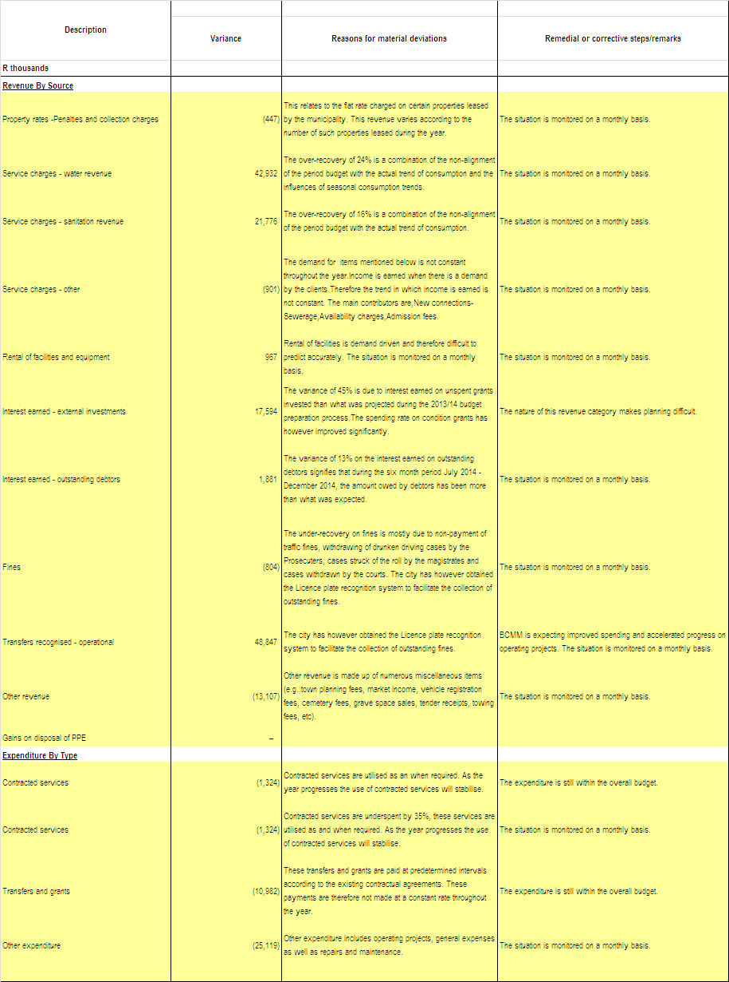
The table below provides material variances (above 10%) for revenue and expenditure.
Table 29: SC9: Monthly Budget Statement – Actuals and Revised Targets for Cash Receipts
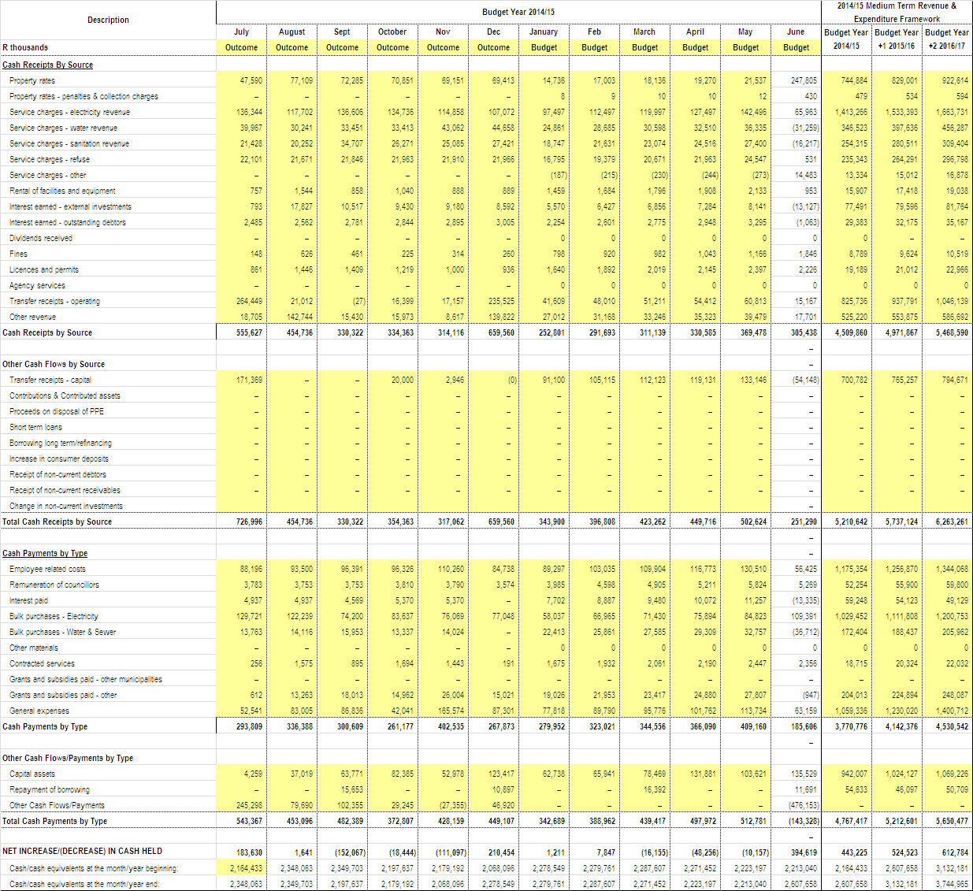
- MUNICIPAL ENTITY FINANCIAL PERFORMANCE
The parent municipality Buffalo City Metropolitan Municipality has constituted the board members for Buffalo City Development Agency (BCDA). The board members convened their their first meeting on 04 April 2014. There are plans to hold a Strategic Planning Workshop before the end of the financial year.

As at 31 December 2014, the Buffalo City Development Agency has a budget of R5,39 million within the Executive Support Directorate of BCMM, and expenditure of R656 931.The expenditure incurred relates mainly to audit fees, accounting fees and board members fees and expenses.

- PARENT MUNICIPAL FINANCIAL PERFORMANCE
The table below provides monthly budget statement performance indicators which have been discussed through out the report.
Table 30: SC2: Monthly Budget Statement Performance Indicators
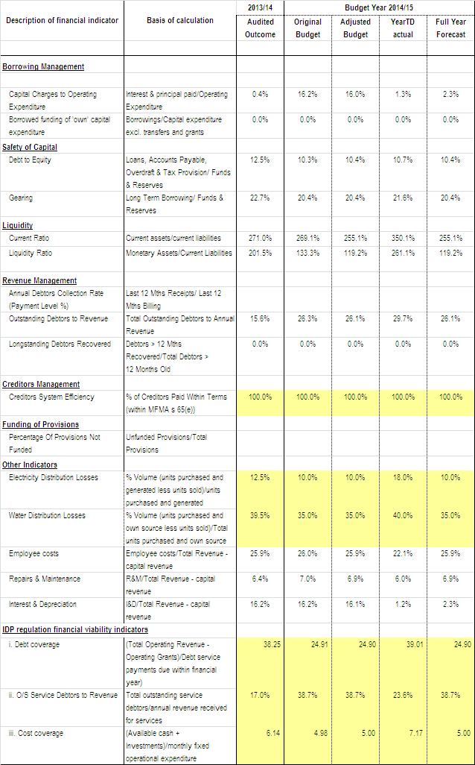

- CAPITAL PROGRAMME PERFORMANCE
BCMM has spent 38% (R397.76 million, inclusive of reclaimed vat) of its 2014/15 adjusted capital budget of R1.06 billion as at 31 December 2014. This reflects an improvement when compared to the same period in the previous financial year where 30% (R289 million) of the adjusted capital budget of R975.10 million was spent.
Refer to Annexure A – C5 for the breakdown per municipal vote, standard classification & funding; Annexure B – SC12 for monthly expenditure trends; SC13a for breakdown of asset classification for new assets and SC13b for breakdown on asset classification on renewal of existing asset). A detailed schedule of the capital projects expenditure is outlined in Annexure E.

Table 31 below reflects capital expenditure performance per source of funding.

Table 31: Capital Expenditure per Funding Source against Budget
Funding | 2014/2015 Rollover Adjustment Budget | YTD Expenditure (VAT) incl) | Variance | % Exp.
Total Own Funding | 331,865,569 | 83,956,049 | 247,909,520 | 25%
DoE(Intergrated National Electrification Programme) | 27,000,000 | 17,330,019 | 9,669,981 | 64%
Department of Sports, Recreation, Arts and Culture | 2,686,285 | 508,900 | 2,177,385 | 19%
Local Government, Traditional Affairs and Housing | 188,726 | 178,585 | 10,141 | 95%
Infrastructure Skills Development Grant | 100,000 | 0 | 100,000 | 0%
BCMET | 256,818 | 0 | 256,818 | 0%
Leiden | 458,860 | 0 | 458,860 | 0%
Neigbourhood Development Partnership Grant | 5,000,000 | 3,067,921 | 1,932,079 | 61%
Urban Settlement Development Grant | 639,824,500 | 264,064,739 | 375,759,761 | 41%
Human Settlement Development Grant | 49,103,948 | 28,669,674 | 20,434,274 | 58%
Total Grants | 724,619,137 | 313,819,838 | 410,799,299 | 43%
TOTAL PER FUNDING | 1,056,484,706 | 397,775,888 | 658,708,818 | 38%

Table 32 below reflects capital expenditure performance per service.

Table 32: Actual Expenditure per Service against Budget
Services | 2014/2015 Rollover Adjustment Budget | YTD Expenditure (VAT) incl) | Variance | % Expenditure
Water | 95,114,971 | 18,902,653 | 76,212,318 | 20%
Waste Water | 220,656,160 | 61,351,352 | 159,304,808 | 28%
Electricity | 137,747,400 | 50,710,215 | 87,037,185 | 37%
Roads and Stormwater | 188,045,000 | 137,673,403 | 50,371,597 | 73%
Housing | 100,776,115 | 63,577,737 | 37,198,378 | 63%
Transport Planning | 56,559,707 | 11,360,479 | 45,199,228 | 20%
Waste Management / Refuse | 95,783,621 | 22,930,167 | 72,853,454 | 24%
Amenities | 57,818,178 | 3,986,562 | 53,831,616 | 7%
Environmental Services | 10,000,000 | 1,579,937 | 8,420,063 | 16%
Public Safety | 14,466,980 | 1,679,425 | 12,787,555 | 12%
Support Services | 47,218,906 | 7,101,363 | 40,117,543 | 15%
Other - BCM Fleet | 32,297,668 | 16,922,597 | 15,375,071 | 52%
TOTAL SERVICES | 1,056,484,706 | 397,775,888 | 658,708,818 | 38%

Table 33 below reflects capital expenditure performance per directorate.

Table 33: Actual Expenditure per Directorate against Budget
Directorate | 2014/2015 Rollover Adjustment Budget | YTD Expenditure (VAT) incl) | Variance | % Exp.
Executive Support Services | 6,840,376 | 287,453 | 6,552,923 | 4%
Municipal Manager's Office | 7,008,500 | 3,407,492 | 3,601,008 | 49%
Human Settlements | 100,828,081 | 63,662,396 | 37,165,685 | 63%
Directorate of Financial Services | 2,817,067 | 54,239 | 2,762,828 | 2%
Directorate of Corporate Services | 23,435,340 | 3,243,107 | 20,192,233 | 14%
Directorate of Engineering Services | 674,361,199 | 285,560,220 | 388,800,979 | 42%
Directorate of Development Planning | 56,559,707 | 11,360,479 | 45,199,228 | 20%
Directorate of Health & Public Safety | 14,466,980 | 1,679,425 | 12,787,555 | 12%
Directorate of Community Services | 163,864,799 | 28,521,076 | 135,343,723 | 17%
TOTAL DIRECTORATES | 1,050,182,049 | 397,775,888 | 652,406,161 | 38%
Asset Replacement | 6,328,657 |  | 6,328,657 | 0%
GRAND - TOTAL | 1,056,510,706 | 397,775,888 | 658,734,818 | 38%

The capital programme performance by month is tabulated in table 34 below (Exclusive of Vat).

Table 34: SC12 Monthly budget Statement – capital expenditure trend
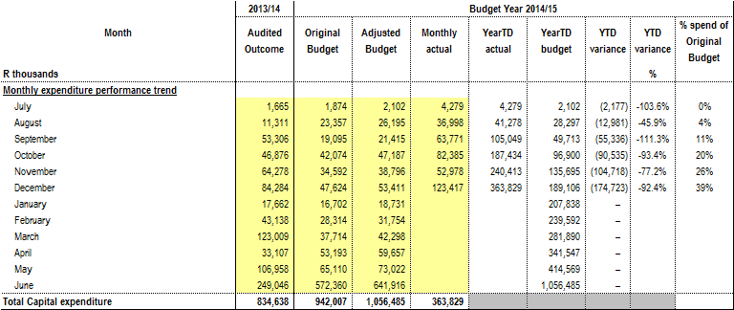

The capital programme performance table 35 below provide summay of capital expenditure by asset class/sub-class for new assets (exclusive of vat).

Table 35: SC13a Monthly budget Statement – capital expenditure on new assets by asset class
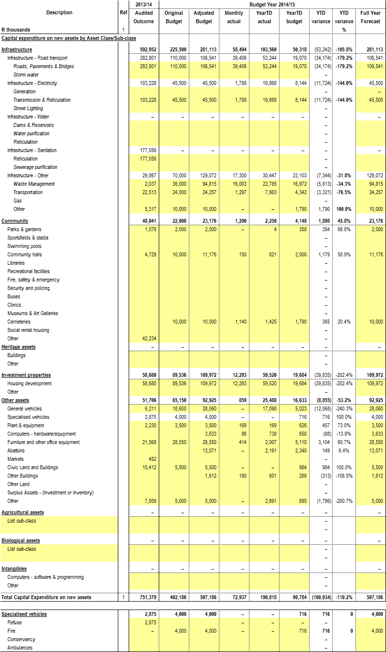
The capital programme performance table 36 below provide summay of capital expenditure by asset class/sub-class for renewal of existing assets (exclusive of vat).

Table 36: SC13b Monthly budget Statement – capital expenditure on renewal of existing assets by asset class
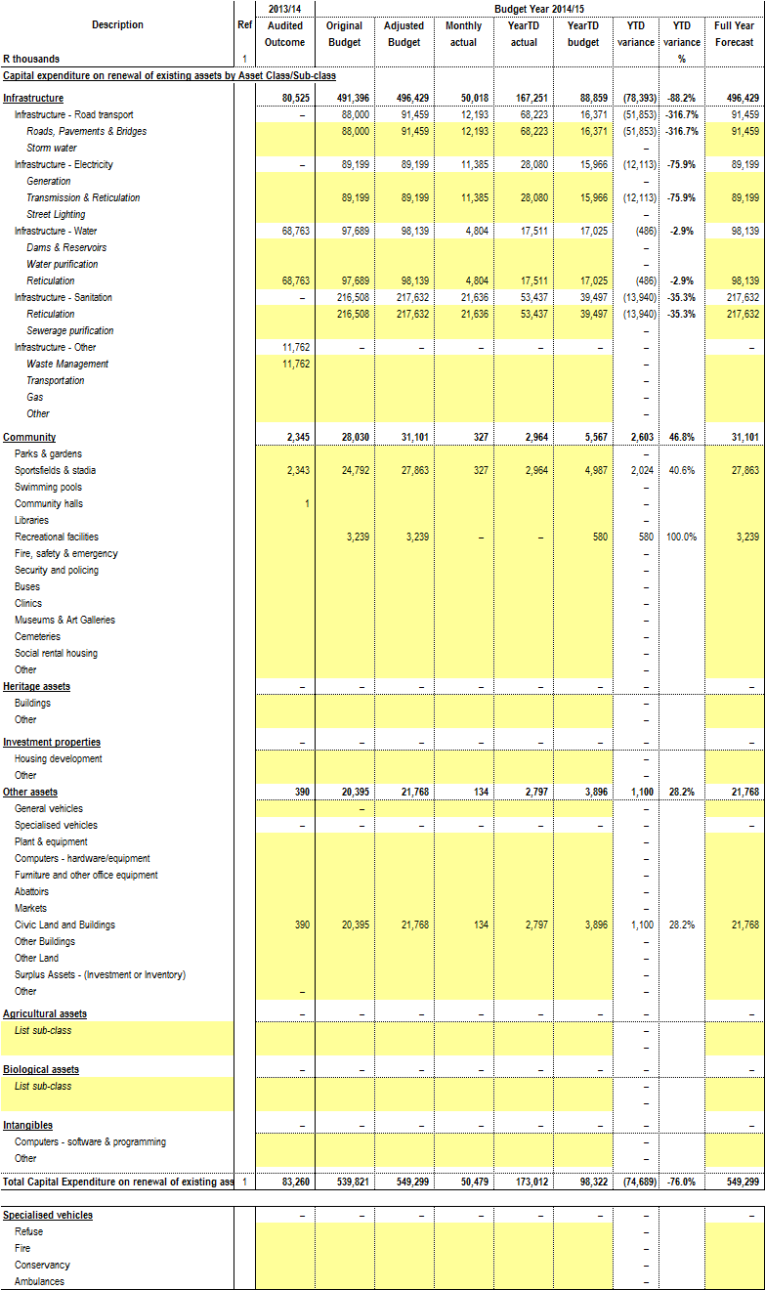
- OTHER SUPPORTING DOCUMENTS
  - Operating Projects Expenditure
The Metro has spent 40% (R114.10 million) inclusive of reclaimed vat of its 2014/15 adjustment budget of R288.44 million as at 31 December 2014. This reflects an improvement when compared to the same period in the previous financial year where 26% (R89.75 million) of the adjusted operating projects budget of R345.45 was spent.

A detailed schedule of the operating projects expenditure is outlined in Annexure D. Tables 37 and 38 below summarise Annexure D.

Table 37: Operating Projects per Directorate

OPERATING PROJECTS PER DIRECTORATE | 2014/2015 Opex Adjusted Budget | YTD Expenditure (VAT) incl | 2014/2015 Variance | % Expenditure
Executive Support Services | 1,755,165 | 339,360 | 1,415,805 | 19%
Municipal Manager's Office | 48,982,809 | 15,209,225 | 33,773,584 | 31%
Chief Operations Officer | 157,268,143 | 74,498,370 | 82,769,773 | 47%
Directorate of Financial Services | 42,961,602 | 6,801,448 | 36,160,154 | 16%
Directorate of Corporate Services | 14,364,938 | 4,272,080 | 10,092,858 | 30%
Directorate of Engineering Services | 2,000,000 | 793,800 | 1,206,200 | 40%
Directorate of Development Planning | 15,723,844 | 9,462,092 | 6,261,752 | 24%
Directorate of Health & Public Safety | 277,788 | 29,930 | 247,858 | 11%
Directorate of Community Services | 5,103,534 | 2,693,000 | 2,410,534 | 53%
 | 288,437,823 | 114,099,305 | 174,338,518 | 40%

Table 38: Operating Projects per Funding Source
OPERATING PROJECTS PER FUNDING SOURCE | 2014/2015 Opex Adjusted Budget | YTD Expenditure (VAT) incl) | 2014/2015 Variance | % Expenditure
Total Own Funding | 82,958,512 | 15,705,280 | 67,253,232 | 19%
Department of Land Affairs | 849,025 | 81,506 | 767,519 | 10%
Department of Local Government & Traditional Affairs | 4,790,672 | 1,171,951 | 3,618,721 | 24%
Department of Sport, Recreation and Arts and Culture | 37,438 | 0 | 37,438 | 0%
Department of Economic Development, Environmental Affairs and Tourism(DEDEAT) | 3,745,411 | 1,651,342 | 2,094,069 | 44%
European Commission | 500,000 | 0 | 500,000 | 0%
Expanded Public Works Programme Incentives Grant | 1,890,000 | 1,543,090 | 346,910 | 82%
Finance Management Grant | 1,500,000 | 694,238 | 805,762 | 46%
Human Settlement Development Grant | 142,523,295 | 72,181,636 | 70,341,659 | 51%
Infrastructure Skills Development Grant | 5,400,000 | 4,057,260 | 1,342,740 | 75%
Leiden | 136,315 | 0 | 136,315 | 0%
Local Government and Traditional Affairs | 6,101,371 | 2,635,182 | 3,466,189 | 43%
Premiers Fund | 67,421 | 0 | 67,421 | 0%
Trust Funds | 2,714,699 | 0 | 2,714,699 | 0%
Umsobomvu Youth Fund | 710,406 | 249,183 | 461,223 | 35%
Urban Settlement Development Grant | 33,464,500 | 14,128,104 | 19,336,396 | 42%
Vuna Awards | 1,048,758 | 532 | 1,048,226 | 0%
Total Grants | 205,479,311 | 98,394,025 | 107,085,286 | 48%
TOTAL PER FUNDING | 288,437,823 | 114,099,305 | 174,338,518 | 40%

  - Income And Expenditure Reports For Directorate Of Health And Public Safety & Community Services

    - Health & Public Safety
Below is the table indicating the breakdown of the Cost Analysis indicating income and expenditure.

Table 39: Health & Public Safety – Cost Analysis
Health & Public Safety | Total Revenue | Employee Costs | Other Operating Expenditure | Repairs & Maintenance | Total Expenditure Excluding Capital
Office of the Dir P/Safety, Health, DM | 0 | 56,746 | 172,661 | 0 | 229,407
Support Services Office | 0 | 796,063 | 53,075 | 0 | 849,137
Health Administration | 0 | 1,565,367 | 273,706 | 0 | 1,839,073
Health Support | 0 | 0 | 35,915 | 0 | 35,915
Pharmacy | 0 | 0 | 9,598 | 0 | 9,598
Clinics | 0 | 0 | 1,741,383 | 11,449 | 1,752,832
Aids Training Information Centre | 0 | 0 | 75,848 | 0 | 75,848
Environmental Health | (394,406) | 7,591,461 | 1,455,110 | 24,446 | 9,071,017
Pest Control | (15,354) | 597,602 | 105,759 | 0 | 703,361
Pollution Control | 0 | 378,704 | 286,981 | 39,370 | 705,055
Educare Centres | 0 | 407,200 | 76,974 | 0 | 484,174
Public Safety Administration | 0 | 1,115,863 | 236,444 | 0 | 1,352,307
Fire and Rescue Services | (40,226,603) | 27,027,887 | 9,345,074 | 390,501 | 36,763,462
Security Services | (2,288) | 32,647,752 | 1,156,082 | 126,581 | 33,930,415
Traffic Administration | (24,985) | 8,868,444 | 9,466,632 | 306,517 | 18,641,593
Traffic Control | (5,865) | 10,564,968 | 379,064 | 5,479 | 10,949,510
Criminal Process | (2,059,589) | 1,491,517 | 60,165 | 0 | 1,551,681
Vehicle Test Station / Examination | (167,332) | 2,015,514 | 122,050 | 425 | 2,137,989
Vehicle Registration | (19,578,104) | 2,104,874 | 99,432 | 0 | 2,204,307
Drivers License Testing | (6,686,423) | 3,273,264 | 335,133 | 0 | 3,608,397
Traffic Technical Services | 0 | 2,069,288 | 105,267 | 105,074 | 2,279,629
Parking Areas / Meters | (1,709) | 2,569,459 | 38,257 | 0 | 2,607,716
Disaster Management | 0 | 894,410 | (260,479) | 17,432 | 651,363
Dog Tax Office | (745,347) | 328,188 | 29,695 | 4,537 | 362,420
Total | (69,908,005) | 106,364,571 | 25,399,826 | 1,031,809 | 132,796,206

    - Community Services
Below is the table indicating the breakdown of the Cost Analysis indicating income and expenditure.

Table 40: Community Services – Cost Analysis
Community Services | Total Revenue | Employee Costs | Other Operating Expenditure | Repairs & Maintenance | Total Expenditure Excluding Capital
Office of Dir. Community Serv. | 0 | 3,016,052 | 416,374 | 3,597 | 3,436,023
Community Services Administration | 0 | 1,154,685 | 122,428 | 0 | 1,277,113
Environmental Administration Support | 0 | 917,388 | 48,818 | 0 | 966,206
Environmental Services | (93,902) | 29,337,209 | 4,688,897 | 292,152 | 34,318,258
Environmental Conservation | 0 | 6,304,505 | 1,886,607 | 14,500 | 8,205,612
Environmental Workshop | 0 | 1,610,478 | 84,853 | 879,580 | 2,574,911
Interments | (3,682,099) | 10,644,475 | 3,226,657 | 101,242 | 13,972,374
Integrated Environmental Management | 0 | 499,548 | 263,959 | 414 | 763,921
Arts & Cultural Serv:Admin | 0 | 4,307,918 | 314,063 | 22,871 | 4,644,851
Libraries | (135,703) | 8,625,545 | 854,405 | 35,006 | 9,514,956
Art Gallery | (503) | 395,112 | 38,590 | 0 | 433,703
Art Centres | 0 | 0 | 9,442 | 0 | 9,442
Halls | (3,310,132) | 5,671,857 | 4,371,413 | 251,209 | 10,294,479
Amenities Administration Support | 0 | 2,623,321 | 781,560 | 149,077 | 3,553,958
Sportsfields | (95,661) | 7,817,647 | 2,170,084 | 161,137 | 10,148,868
Swimming Pools | (243,931) | 4,954,381 | 771,659 | 50,845 | 5,776,884
Aquarium | (58,451) | 3,714,863 | 619,469 | 37,429 | 4,371,761
Zoo | (732,627) | 2,396,006 | 838,441 | 102,498 | 3,336,945
Beaches | (54,685) | 6,431,821 | 1,412,227 | 322,775 | 8,166,823
Resorts | (675,066) | 2,565,155 | 709,243 | 248,133 | 3,522,530
Cleansing Administration Support | 0 | 4,162,746 | 7,614,233 | 1,838,001 | 13,614,980
Refuse Removal | (183,089,910) | 22,077,026 | 69,368,518 | 6,057,092 | 97,502,635
Waste Disposal Sites | (1,653,885) | 995,238 | 3,185,382 | 0 | 4,180,620
Street Sweeping | (3,513) | 21,982,105 | 367,315 | 0 | 22,349,420
Public Conveniences | 0 | 2,644,831 | 1,017,180 | 0 | 3,662,011
EL Regional Waste Disposal Site & Transfer Station | 0 | 3,174,108 | 8,956,510 | 0 | 12,130,618
Total | (193,830,070) | 158,024,018 | 114,138,326 | 10,567,556 | 282,729,900

  - Repairs and Maintenance
The table below detail expenditure on repairs and maintenance by asset class.

Table 41: SC13c Monthly budget Statement – repairs and maintenance by asset class
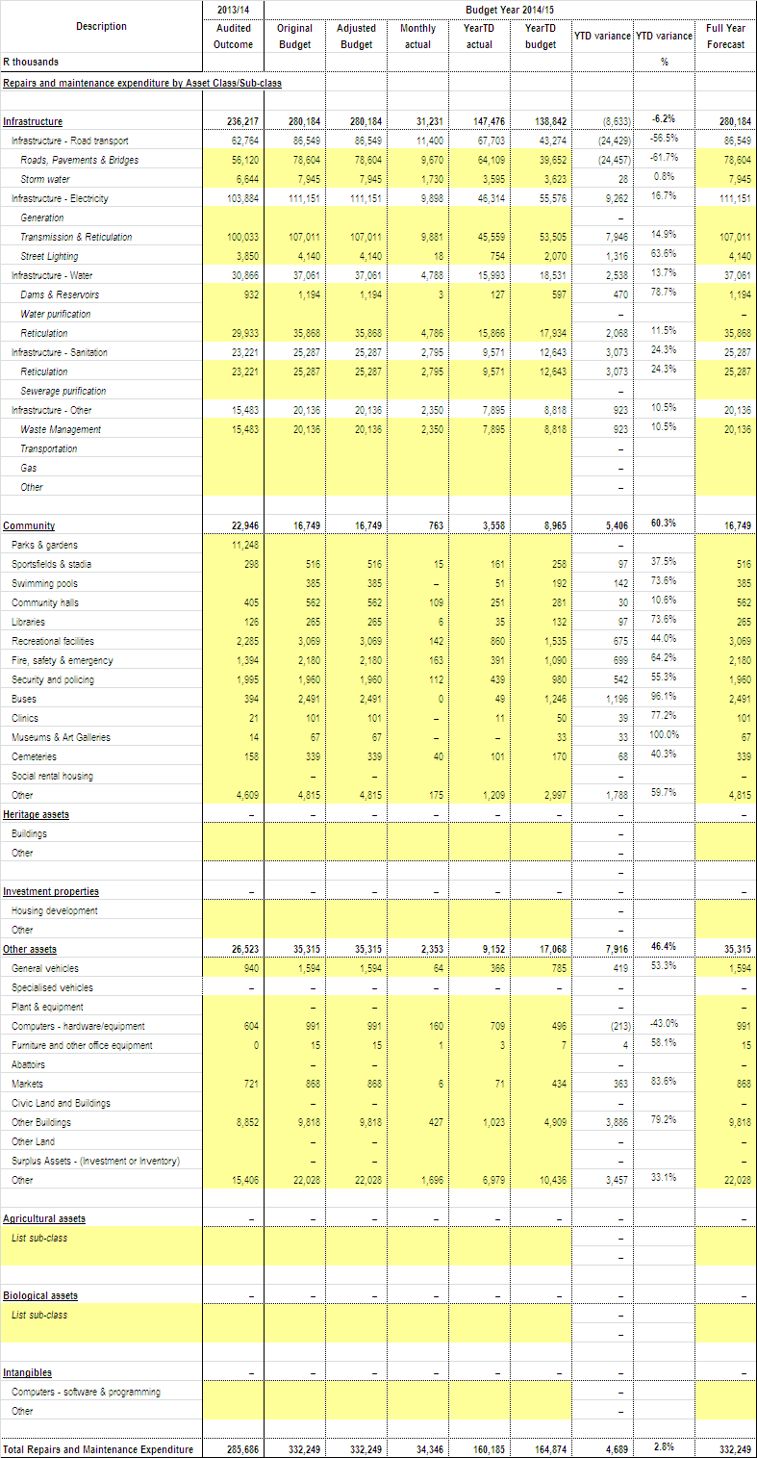
  - Depreciation
The table below details depreciation by asset class.

Table 42: SC13d Monthly budget Statement – depreciation by asset class
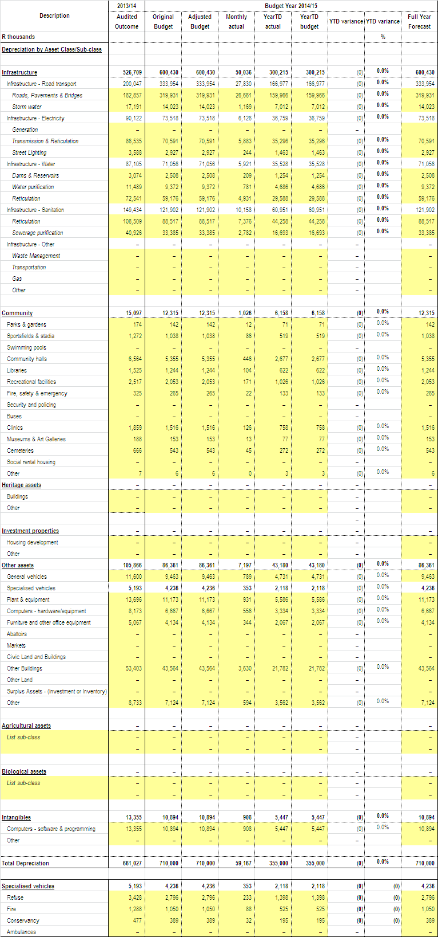

- MID YEAR ADJUSTMENT BUDGET FOR THE 2014/2015 FINANCIAL YEAR
The enclosed performance report will be analysed in terms of its revenue projections and expenditure categories which will culminate in the Mid-year adjustment budget to be tabled in a Council meeting in February 2015 in terms of S28 of the MFMA.

- SUMMARY OF PROGRESS MADE ON RESOLVING PROBLEMS IDENTIFIED IN THE PREVIOUS YEAR’S ANNUAL REPORT
  - Audit Findings
The 2012/13 audit report highlighted qualifications in the following areas:
- Property, plant and equipment-Electrical & Buildings and
- Irregular expenditure

These qualification areas were focused on during the 2013/14 financial year with a complete review of the electricity infrastructure assets being performed, together with a complete reanalysis of the building portfolio. Initial Auditor General reviews suggests positive results in this area.

An adjustment was processed in the 2013/14 Annual Financial Statements to the prior year irregular expenditure in an attempt to correctly record all irregular expenditure.

A detailed report on the audit outcomes will be presented to Council concurrently with the tabling of the Annual Report. An audit improvement plan is being developed from the outcome of the detailed management letter.

  - Expenditure Management
Expenditure has shown a positive trend through increasing year on year both in terms of Operating and Capital Projects.

There were however challenges experienced through awarded tenders being challenged through the litigation process and a limited number of service providers tendering for the projects, resulting in one contractor being awarded a number of projects contributing to service delivery delays.

The following mitigating factors have been implemented:
- The Bid Committee are being tasked to convene regularly to ensure that there are no backlogs in the tender process
- Due diligence is being performed on the successful tenderers
- The Implementation of Procurement Planning will also significantly improve expenditure patterns and reduce need for roll-overs

  - Revenue Management
The following challenges were experienced:
- Illegal connections
- Unread meters due to accessibility
- Indigent consumers using excess of 6 kilolitres of water which cannot be recovered
- Flat rates being charged in unmetered areas

Below are the corrective measures that are being implemented:
- The appointment of the reconnection and disconnection team to assist in monitoring the illegal connections.
- Council has approved the turnaround plan to mitigate water losses and ageing infrastructure assets as well as the implementation of new meters in unmetered areas over a period of 3 years.
- Number of meter readers has been increased with close supervision and monitoring.

  - Asset Management

The institution has identified the area of asset management of critical importance to the institution. In this regard a staff structure has been prepared and included in the Council approved organogram. A service provider has been appointed on a 3 year basis to assist with preparing fixed asset registers, infrastructure asset management plans and a comprehensive municipal infrastructure plan. As part of their appointment there is a requirement to assist in the creation of an internal asset management unit. It is envisaged that upon conclusion of this project there will be a strategic plan for the infrastructure development in the metro and the limited resource of funding will be focused on the areas identified in these documents.

- MUNICIPAL MANAGER’S QUALITY CERTIFICATION

QUALITY CERTIFICATE

I, ANDILE FANI, the City Manager of Buffalo City Metropolitan Municipality do hereby certify that –
- Mid-year budget and performance assessment (Section 72 Report)

for the period ending December 2014 has been prepared in accordance with the Municipal Finance Management Act 2003 and Regulations made under that Act.

Print name: ...........................................

City Manager of Buffalo City Metropolitan Municipality, BUF

Signature: ..........................................

Date: ...............................................

ANNEXURES:

Annexure A
C1 Monthly Budget Statement - Summary
C2 Monthly Budget Statement - Financial Performance (Std Classification)
C3 Monthly Budget Statement - Financial Performance (By Municipal Vote)
C4 Monthly Budget Statement - Financial Performance (Revenue and Expenditure)
C5 Monthly Budget Statement - Capital Expenditure (Municipal Vote, Std
Classification and Funding)
C6 Monthly Budget Statement - Financial Position
C7 Monthly Budget Statement - Cash Flow

Annexure B
SC1 Material Variance Explanation
SC2 Performance Indicators
SC3 Aged Debtors
SC4 Aged Creditors
SC5 Investment Portfolio
SC6 Transfers and Grants Receipts
SC7 (1) Transfers and Grants Expenditure
SC7 (2) Expenditure against approved rollovers
SC8 Councillor and Staff Benefits
SC9 Actuals and Revised Targets for Cash Receipts
SC12 Capital Expenditure trend
SC13a Capital Expenditure on New Assets by Class
SC13b Capital Expenditure on Renewal of Existing Assets by Class
SC13c Expenditure on Repairs and Maintenance by Asset Class
SC13d Depreciation by Asset Class

Annexure C
Schedule of Borrowings

Annexure D
Operating expenditure report

Annexure E
Capital expenditure report

Annexure F
Service Delivery and Budget Implementation Plan

